ATTACHMENT 1

Development of Epic Grip

By Beer van der Drift

# WARNING: Basic knowledge on C# is needed to fully understand certain parts in this Attachment.

# Development of Epic Grip

# Starting the Project and explaining the “GameMain” class

I first have to create a project in the Visual C# program. I select “New Project” and a screen comes up. Although I will make this game compatible with the Xbox360 later, I will for now select “Windows Game (4.0)”. This will create some pre-rendered code I will come to in a moment, and some methods and classes for me to use for graphical and storage devices. I now have to select a name, and I will call it for now “PWS”. This immediately creates 2 classes. The “Program” class containing the “Main” Method (The first method started by the computer, see it as the first domino kicked over, but in this block of code you have to write what to do next). This “Main” method is already filled with code to start the “Game”, I will never touch this class or need this class, so I will close this and never look back to this again. I can’t explain this code in a good manor, because I never went in-depth in this method. This is in the “Program.cs” file.

**CODE:**  
namespace PWS

{

#if WINDOWS || XBOX

static class Program

{

/// <summary>

/// The main entry point for the application.

/// </summary>

static void Main(string[] args)

{

using (Game1 game = new Game1())

{

game.Run();

}

}

}

#endif

}

The project also has another standard class-file, named “Game1.cs” which contains the “Game” class. In this class there is a bunch of code pre-written which I will explain later. The class itself is named “Game1” and is referred to (as seen in above code) to “Game1”. I change the name of “Game1.cs” to “GameMain.cs” to keep track of what class is used for what. Visual Studio promps me if I’d like to change all references in the file and other files from “Game1🡪GameMain” and I accept. This changes every “Game1” to “GameMain”, including in the code shown above.

REMEMBER: Until I say otherwise, all of the code I explain now, is pre-written by the XNA 4.0 Developers.

First the “GameMain” class declares 2 variables:

**CODE:**

GraphicsDeviceManager graphics;

SpriteBatch spriteBatch;

What this does is create a Device Manager for the Graphics Device. I can now use this manager to change resolutions of the game, and swap from fullscreen mode to windowed mode and vice versa. The other variable created is the Sprite Batch. With this I can draw graphical object and strings to the game window. I will use this very often in the “Draw” method, the method used to draw things to the screen.

The next block of code is called the “Constructor”.

**CODE:**

public GameMain()

{

graphics = new GraphicsDeviceManager(this);

Content.RootDirectory = "Content";

}

This is a block of code immediately called when an instance of this class is set up. So when it says

“GameMain game = new Game1()”

in the “Program.cs” file an object of “GameMain” is created named “game” which immediately is set up as a “new GameMain()”, the GameMain() part being the block of code I just showed you, being the constructor. In this block of code you set up variables, and where you initialize the initialization process (sounds weird, I know). The “graphics” variable is set up as a new manager, as you can see. The constructor requires the user to pass on of what game the manager is controller, being the GameMain class you are currently writing in, being “this”. The RootDirectory is set up as “Content”. With these classes a folder was created as well, named “Content”. The RootDirectory value of the Content-property is the root-folder for when a user makes the ContentManager search for content.

Next, the game has to be Initialized, filling the variables with values which with they have to be filled with. I currently have no object to be initialized so this class is empty.

**CODE:**protected override void Initialize()

{

base.Initialize();

}

as you see the “base.Initialize();” method is called. This initialize things I don’t know of, used by the game and which the user/programmer may not touch, because these things are necessary. You will see this base.something more often, remember: this is to initialize things which may not be differed by the user.

The next block of code is the “LoadContent” method, used for loading graphical content and audio into the game. This is used for setting up variables for graphical purposes as well, as you can see:

**CODE:**protected override void LoadContent()

{

// Create a new SpriteBatch, which can be used to draw textures.

spriteBatch = new SpriteBatch(GraphicsDevice);

}

After this comes the Update class, with the parameter “GameTime” (used for keeping track of the time the game has been played, and time elapsed since last update). In this class you update your game, by i.e. user input or random generators. This is what the game drives on, and this code is being called hundreds of times per second.

**CODE:**

protected override void Update(GameTime gameTime)

{

// Allows the game to exit

if (GamePad.GetState(PlayerIndex.One).Buttons.Back == ButtonState.Pressed)

this.Exit();

base.Update(gameTime);

}

This block now has a pre-written piece of code, for when the player one presses on the “Back” button on their controller, the game(this) will exit. I will delete this line, because this is a suggestion by the XNA developers, but I will create my own methods to exit the game.

The next and last block of code is the “Draw” class. In this Draw class all the code for drawing to the screen has to be written. Since I will use only 2D graphics, I will use the SpriteBatch provided. I will first show you the clean code, and then how I change it ready to draw 2D graphics.

**CODE:** protected override void Draw(GameTime gameTime)

{

//Clear the screen of any previously drawn stuff,

//creating a clear blue screen.

GraphicsDevice.Clear(Color.CornflowerBlue);

base.Draw(gameTime);

}

The SpriteBatch needs to start before anything can be drawn, and end before the “Draw” block can be ended. So I add the code:

spriteBatch.Begin();

spriteBatch.End();

Making the complete method:

**CODE:**

protected override void Draw(GameTime gameTime)

{

//Clear the screen of any previously drawn stuff,

//creating a clear blue screen.

GraphicsDevice.Clear(Color.CornflowerBlue);

spriteBatch.Begin();

//Write code for drawing here

spriteBatch.End();

base.Draw(gameTime);

}

If I now boot up the game, I will get Figure 1:

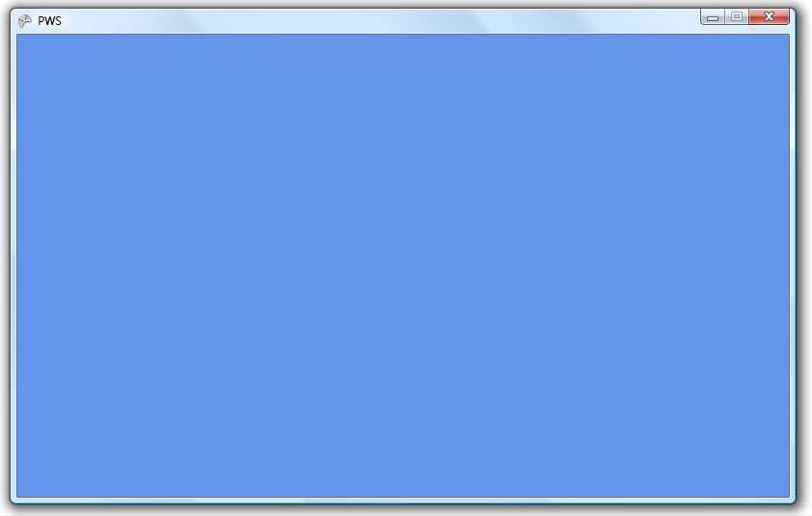

*Figure 1 – The initial game screen.*

A window coloured “CornFlowerBlue”, which is the colour chosen in the previous block of code. I can’t see my mouse when I move it inside the window, which I can change later. A thing I immediately notice is that the size of the window has no logical size, so with this line of code I change it in 720p (HD Ready)

**CODE:**

graphics.PreferredBackBufferHeight = 720;

graphics.PreferredBackBufferWidth = 1280;

graphics.ApplyChanges();

So everything is ready to go, lets program the ScreenManager!

# Programming the ScreenManager and creating screens

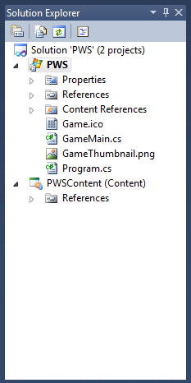For every screen I want I will have to create a new class. I have a nice “Solution Explorer” on the right side of my screen which makes me order all the files I have.  
  
The game thumbnail is a little image which will represent the game’s thumbnail. This image will represent the game in i.e. the Xbox Dashboard. I will not touch this image now, but after the game is done. Let’s first create a new folder named “Screens” which will contain a .cs file for every screen the game will have. I will create .cs files for the basic screens now, but not program them yet. I create a class named “MainMenu.cs” in the folder “Screens”. This will be the only file I create so far, because that is the only screen I want to develop right now.

Something I will need in the game and menus is a button, so let’s focus on creating that first.

# Creating a button

I make a new folder named “Controls” and create a new class in there named “Button.cs”. With the “using” statement on top of a file I can tell the program what classes I want to use from different namespaces (folders in programming language). Since I have the “Sprite.cs” class I need to use for drawing things to the screen. I gained this Sprite class by previous development by myself. It is a basic *Figure 2 – The Solution Explorer* class which makes me able to render an image easily to the screen. I will add this line of code:

**CODE:**  
using PWS.Graphics;

This is because the “Sprite” class is in the PWS.Graphics namespace. If I wouldn’t use this “using” statement I would have to write “PWS.Graphics.Sprite” everytime I want to use that class.

Now in the actual class I need to create some variables. I need a sprite for the button, a colour for when the mouse hovers over the button or is selected, a colour for when the button is pressed and a colour for when the button is released. I also need a “state” in which the button is at that moment. So above the actual code I will create an enumeration named “BTNState”. A “string” variable has to be created as well for the button text. 2 other variables I have to add are the position as a “Vector2” variable and the “font” variable.

**CODE:** enum BTNState

{

Released,

Selected,

Pressed,

}

Now I can give the button class some variables named above. I will also add the “Properties” for the class. Variables are usually used in a “private” way, which means that only from inside the class the variables can be changed. These “Properties” are a sort of “Doorway” for other classes to change the variables values.

After this I will have to create the standard methods, such as Initialize, LoadContent, Update and Draw method. The Initialize method needs a parameter for the text on the button. The LoadContent method needs a parameter called “ContentManager” to read the texture from the Content folder. A constructor has to be created as well. In this constructor all the objects have to be instantiated if necessary. After this I have to write the code for the Initialization process. I give the released state colour white, the selected state colour green and the pressed colour dark green.

In the “LoadContent” method I have to give the sprite a texture to represent. I put the “Button.png” file in the “Controls” folder of the “Content” folder. I also have to load a font for the text, I have loaded this font into the “Controls” folder already. So now this is my LoadContent method:

**CODE:** public void LoadContent(ContentManager content)

{

sprite.LoadContent(content.Load<Texture2D>("Controls/Button"));

font = content.Load<SpriteFont>("Controls/ButtonFont");

}

The “<>” part states what type of item has to be loaded, because with this method you can load audio as well.

For the “Update” method I have to make sure the button has the colour of the right state. With some simple if/else blocks I create the code that “if the button is this state, the sprite has that colour”. The position of the sprite has to be the same as the position of the button class, so that creates another line of code.

Now comes the more difficult part; drawing the text in the correct space on the button. There is no option to “Center” the text, so I have to calculate the position myself. I know the buttons sprite is 256x64 big, so I can use these dimensions. But this point will represent the top-left corner of the string. So I have to do 256 divided by 2, minus the length of the string divided by 2 for the X position, and something similar for the Y position. Luckely the font has a method for calculating the width and height for the string, and I use them to my advantage to create a new Vector2(x, y):

**CODE:**new Vector2(256 / 2 - font.MeasureString(text).X / 2, 64 / 2 - font.MeasureString(text).Y / 2)

So now that the code is probably finished, I have to debug the code. I will do this by just creating a button in the “GameMain” class quickly. I will Initialize, Load Content, Update and Draw it there. When I boot up the game I get Figure 3:  
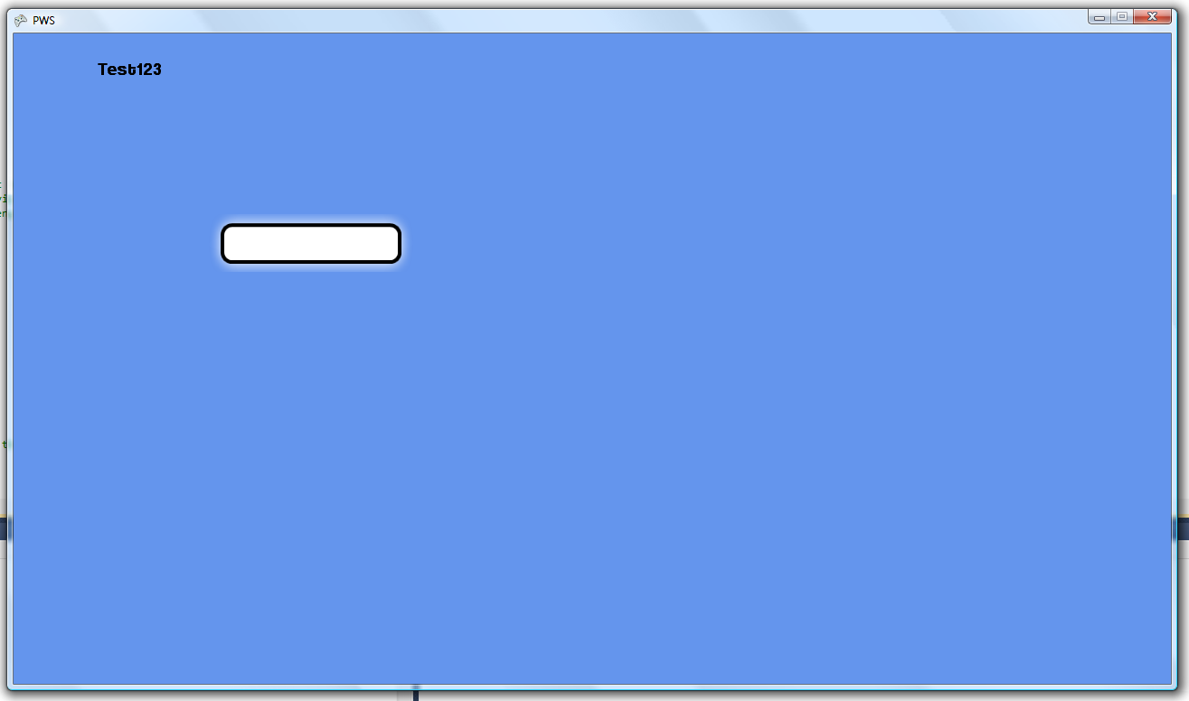

*Figure 3 – Attempt to draw a button to the screen*

OOPS! We got a problem, which is quite obvious; I set the button on the position 200x200, but the code for determining the position of the text, only gives the position IN the button texture, so I now have to adjust the code to keep in mind the position of the button as well.

So after further testing and changing the font the button works fine. I won’t have to test the states yet, because those will only work when with groups of buttons. Let’s go back to program the button groups for the Main Menu.

# The Main Menu and groups of Buttons

I want a scrollable group of buttons. So first I have to create a “ButtonGroup” class, in the “Controls” folder/namespace. Of course this class needs variables as well. I will create a list for every object needed, such as the buttons and text on the buttons. I will also create an array for the positions and a “int”(integer) variable for the currently selected button. The class needs the basic methods as well. You can imagine the class from what I did in the previous heading, so I won’t explain the further basic steps. You should be able to make out what I have done through the “//” comments in the code.

I have to decide what the value has to be of the “spacing” variable. I do this by using the line of code:

**CODE:**spacing = 720 / (ButtonCount - 1);

This is because I will multiply the “spacing” value to the position (so if the position is 1st, it will state: 0*spacing. This is because in programming you most often start counting at 0). But I still want the last position to be 720p. And say ButtonCount = x, the last position would be x-1. So that will never make 720. That’s why I add the (ButtonCount – 1) part. I want the selected button to be the middle button on the screen, but because I want to create a code where you can add any amount of buttons, I first have to calculate what position the middle button has to be. I just divide the amount of amount of buttons by 2, which can return a half number in case of an odd total number. This does not matter because the position is relatively to the screen, so it always has to be the centre. Now again a difficult part: assigning positions.

So I want the first button to be in the middle of the screen, and the last ones to be above the first button. I have created this small algorithm to do so:

**CODE:** for (int i = 0; i < ButtonCount; i++)

{

if ((float)i < (float)ButtonCount / 2)

{

positions[i] = middlePosition + i;

}

else

{

positions[i] = middlePosition - (ButtonCount - i);

}

}

Any programmer is familiar with the “for” statement. The block of code between the brackets will be repeated for a set amount of times. I use the i variable as the representation of a button, i = 0 being the 1st button etc. First the code checks if the button is below the half of the amount of buttons, and if over it sets the position from above. This will create Figure 4, after setting up 5 buttons:

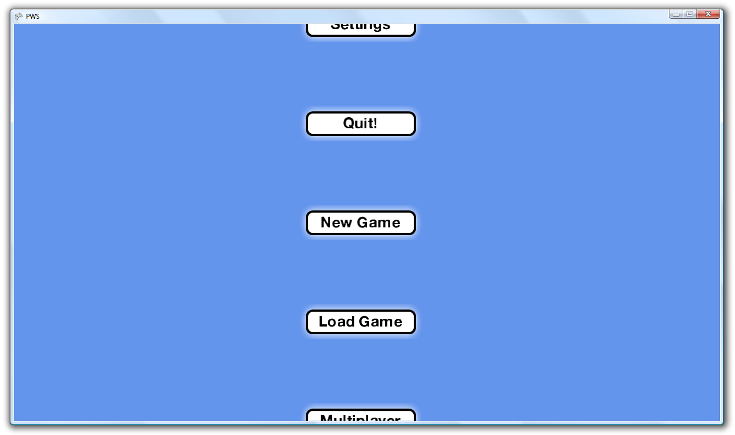

*Figure 4 – The ButtonGroup class drawn to the screen*

With “New Game” being the first button in the array, and the “Quit!” button being the last one.

I have to code the group in such a way, that always the middle button is the button selected. This is done in an easy way, just by saying that the button with the position buttonCount/2 is the one selected, giving me Figure 5 as outcome:  
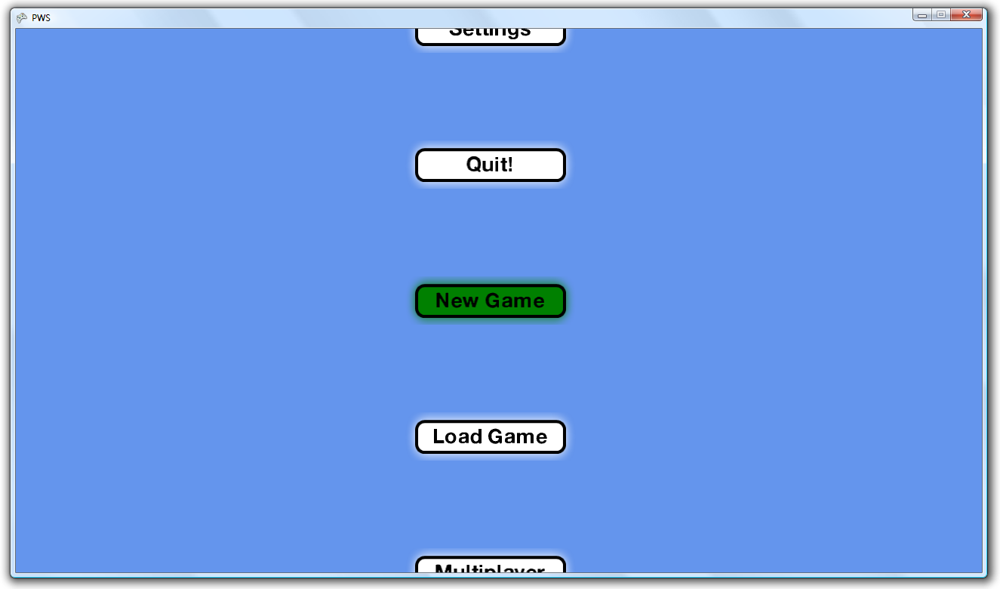

*Figure 5 – The middle button is selected*

So let’s start the coding for the scrolling now!

I want the group to scroll in such a fashion that everything rolls smoothly, much like a wheel. With accelerating speed, but still a maximum speed. When the player releases the joystick the wheel needs to brake in such a fashion. Let’s assign the acceleration first. The acceleration needs to decrease the faster the wheel goes, so I write this line of code:

**CODE:**

acceleration = (1 - Math.Abs(ySpeed / maxSpeed)) * maxAcceleration;

This returns a number based on the percentage of how close the actual speed is to the max speed. For the deceleration I use the same code, but I delete the (1 – part, because that will switch the acceleration around to deceleration. I also create a small algorithm that makes the button jump to another position, giving the illusion of actual scrolling. This jumping of position only happens when the amount of scrolling covered equals the “spacing” variable. This class nearly finished, it only needs an extra button to create the illusion of an actual button coming in the screen, since it now only teleports the button moving away from the screen to the first position in the screen. For this I create an extra button which comes in/moves out on the top, and the same text should be shown on the button. So both buttons need to be a copy of the button moving out of the screen. The position of the bottom button is the last position + 1 and for the top button the first position – 1. And ofcourse adapted to the percentage moved. Now we have this ButtonGroup ready to go after the debugging! The way I programmed this class is perfect, since it works with ANY number of buttons!

# The ScreenManager class

The next step we need to take is to create a manager for every screen, which sounds difficult but is quite easy to make. First I create a class named “ScreenManager” in the Screens folder. This class contains a enumeration for the screens and an actual class, the screenmanager. I need to create a reference for every screen I will make available. This will be my enumeration:

**CODE:**enum CurrentScreen

{

StartScreen,

MainMenu,

LoadMenu,

SaveMenu,

SettingsMenu,

SignInMenu,

PlayScreen,

ScoreScreen,

UpgradeScreen,

CustomizeScreen,

}

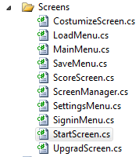Of course the basic methods like Initialize and LoadContent are needed as well, so I create them. But to work with these screens, I need to make them first. Because every screen is only needed once, I make the classes static, which means I do not make an object of them, and work with that object, but just directly with the class itself. Let’s create a class for every screen (see Figure 6). There are multiple rules for creating a game for the Xbox marketplace, and one of the requirements is that player one does not has to be controlled by controller one. For this I need to make a start screen, the standard “press start” screen we know. Such as every other screen class I need a the basic methods as well. From now on I will only note it down when I do NOT create the standard methods. *Figure 6 – The screens*

How do the other classes know which controller is controlled by player one? Simple! I created a class file, with not a class in it, but a structure, or a “struct”. This is a variable, which contains basic information. The information my structure named “InfoPacket” contains is which controller belongs to which player, and the gametime variable. This packet will be passed on to every Update method I create, and so every class can retrieve the information from the packet!

So I scan every controller in the Update method of the Start Screen for a pressed start button, and if I get a positive result, the “PlayerOne” value in the info packet is changed to the corresponding controller. The next line of code changes the current screen from the screenmanager to the “MainMenu”, so the startscreen won’t be updated or drawn anymore, but the MainMenu screen will!

But the startscreen is not yet finished! It now looks boring, so let’s create a background! What I found in Paint.NET is that I can give effects to drawings I made. So with some experimenting I found the perfect backgrounds! I wanted to create something with not extremely bright colours, but playful colours, so I created a frame of 1280x720, and gave it 1 egal colour. This is one example:



*Figure 7 – Background with egal colour*

Then I drew some lines on it with a bit darker shade:

  
*Figure 8 – Background with darker lines drawn on the egal background.*

But this didn’t look very attractive, so I added the “Gaussian Blur” effect, giving me Figure 9:

  
*Figure 9 – The background after blurring Figure 8*

This is a basic, but easy to watch at background. I repeated this step with multiple colours so now I have 6 very basic backgrounds in different colours! I import all of these images to my “Basic Backgrounds” in my “content” folder. I now make the code of i.e. start menu choose a random background from that folder, giving me a varying start menu every time the game is started! See this screen as an example:

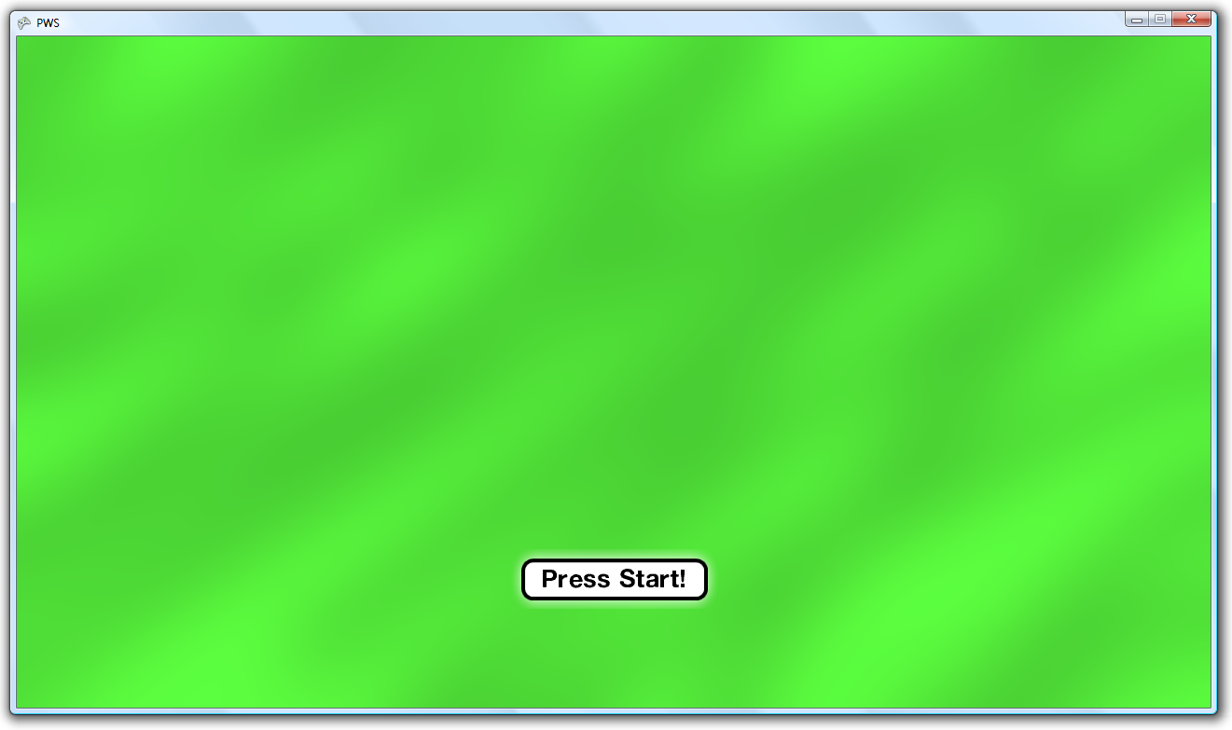  
*Figure 10 – The start screen*

Of course a nice logo will be added later, to make the start screen more attractive, but for now, this will do!

The next screen I would like to develop is the main menu. This menu will have the same way to choose a background, but it will repeat the process. This way there will be a chance (5/6) that the background will change. If I like I could make more backgrounds later for a greater variety, but I am satisfied right now! So I will not use the same buttons as I used with testing, I now use 7 buttons which are:

**CODE:** texts[0] = "New Game";

texts[1] = "Load Game";

texts[2] = "Multiplayer";

texts[3] = "Customize!";

texts[4] = "Upgrades";

texts[5] = "Settings";

texts[6] = "Quit!";

I position this buttongroup in such a way that there is enough room on the right to add any extra graphics for the looks later! After finishing the code I have this as a result:

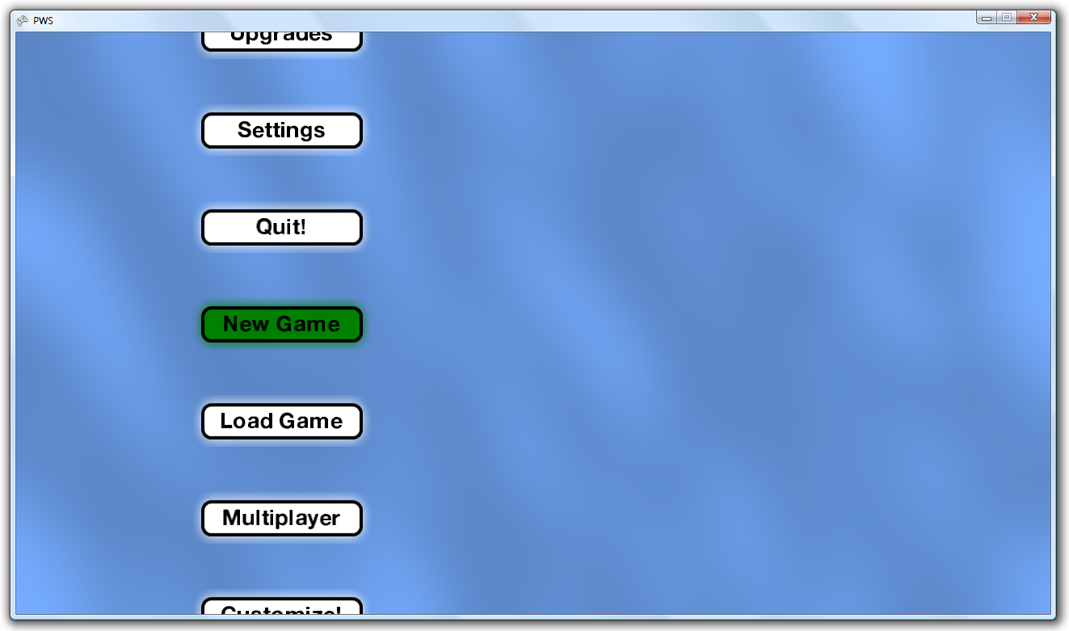  
*Figure 11 – The Initial Main Menu*

This looks very nice and all, but the buttons have no functions yet, so let’s create them! All these buttons have to do is switch screen (except for the Quit button), so this is easy to program. This is code for example for quitting:

**CODE:** if (buttons.CurrentlySelect == 7)

{

infoPacket.TheGame.Exit();

}

I added the “GameMain” variable to the infopacket, this way I can exit the game trough other method and classes. The line of code between the brackets is at the other blocks replaced by something in the sense of: CurrentScreen = <Screen corresponding with button>. After testing everything works. I made the “New Game” button the same as the “Multiplayer” button since I want to focus on the multiplayer aspect first. The LoadGame button will do nothing, since there is no single player to load.

First I have to design the sign-in menu. It will feature 4 blocks, for every player one, with every block containing text which says something like: “Player <X>, please press start!”. Of course the first player has signed in already in the first screen! I will again use a standard background, and a nice smaller background in the middle for the four blocks, which is shown in Figure 12:

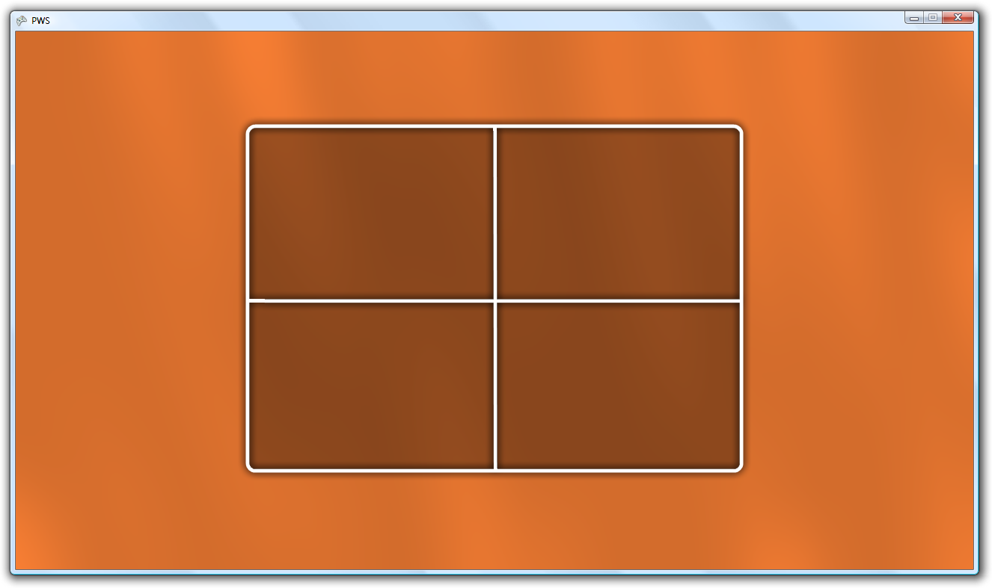  
*Figure 12 – The Sign in Menu*

I would like a text at the top saying something like: “Player selection!” which again I will add later, since I don’t want to achieve this by simply drawing a string to the screen. I want a player’s gamertag featured in a block when signed in, so I have to load these as well. I added four “Gamer” profiles to the packet, so I can use these. The player will be forced to log in to an account before he can start playing. The difficult part is the positioning of the texts. I can’t just say: centre the text and place it there, since there is no centre option. I have to calculate the position myself. What I do is, I split up the logged in accounts boxes in 2 lines, and the yet-to-login boxes in 1 line. The yet-to-log in box has to say:

“Player <X>, please press start!”

and the logged in boxes will say:

“Welcome <Name>!   
 Press A to begin!”

The middle of the first box is the entire box / 4 (for x and y value). Let’s use this code to explain:

**CODE:** LineOne = "Welcome " + playerOne.Gamertag + "!";

LineTwo = "Press A to start!";

LineOneDimensions = font.MeasureString(LineOne);

LineTwoDimensions = font.MeasureString(LineTwo);

spriteBatch.DrawString(font, LineOne, new Vector2(465 - LineOneDimensions.X / 2, 225 - .75f * LineOneDimensions.Y / 2), Color.White);

spriteBatch.DrawString(font, LineTwo, new Vector2(465 - LineTwoDimensions.X / 2, 225 + .75f * LineTwoDimensions.Y / 2), Color.White);

I first fill the lines with text. Then I get these string measured, which will return a width and height represented by a X & Y. I now call the DrawString method, which asks for these values:

* A SpriteFont
* The String
* The Position
* The Colour of the text

I already have the font, string and colour ready to use, but I still have to give the position. The position of the big box is 290 ((1280 – 700) / 2), 110 ((720 – 500) / 2). The width of the box is 700, so the centre of the left box is 700/4 = 175. To get the position on the screen I add 175 to 290, which gives 465. I search the centre for the Y value as well, and put the first line a bit higher and the second a bit lower. I do similair steps for the other boxes, but those are not logged in yet. This gives Figure 13:

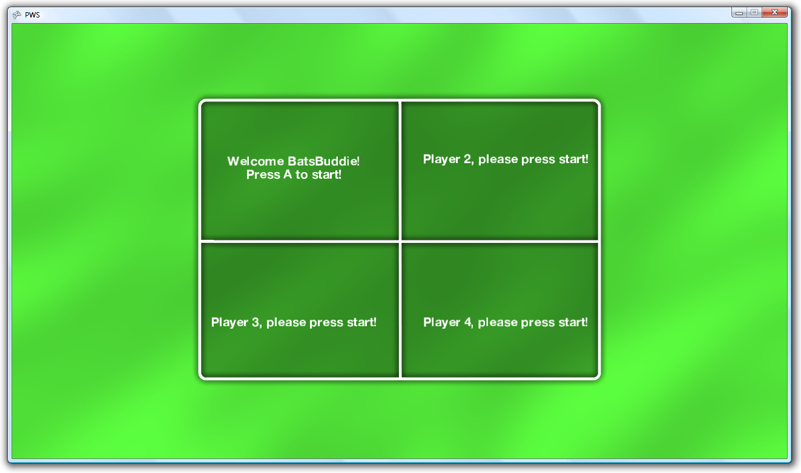  
*Figure 13 – The Sign In menu with text*

Don’t mind the name, I had to choose something random :D. You can see the texts seem a bit off, this is because this is actually the size of the box: 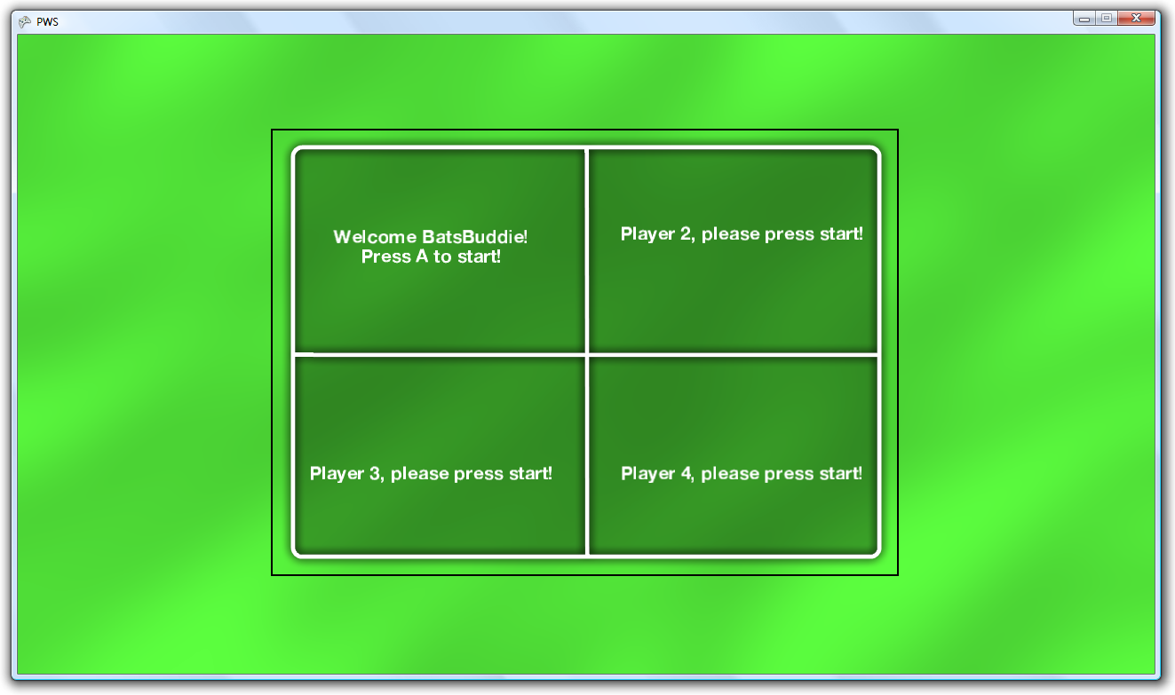  
*Figure 14 – The Visual Box, and the actual bounds visualised by black lines*

I don’t mind it that much, so I will not use my time now to fix this. I now encounter a problem! Since the code is written for windows systems and the framework is made by windows, they implemented everything for “Windows Live”, the windows gaming service. On Xbox every controller can sign in to a different account, so every player is represented by a different account. It seems to be the case that this cannot be done on the PC, so I continue programming on the Xbox first, and finish the game for the PC later. I create a new project named “PWSXbox” and copy EVERYTHING I have made from the PWS project to the PWSXbox project. I do not need to change ANYTHING, because the code is suitable for the Xbox as well! So after testing and designing I came up with this algorithm to check if a controller is logged in, and if a logged in controller has logged into the game yet. See this code:

**CODE:**class SigninMenu

{

static SignedInGamer[] players;

static public void Update(ref InfoPacket infoPacket)

{

//Update the backgrounds

background.Update();

selectorBackground.Update();

//Update the profiles

players = infoPacket.PlayerProfiles;

//Check every controller

for (int i = 0; i < 4; i++)

{

//Is the player pressing the start button?

//Then start the code!

if (GamePad.GetState((PlayerIndex)i).Buttons.Start ==

ButtonState.Pressed)

{

//Create a boolean to check if player is logged in already

bool falseLogin = false;

//Check if there are actually <nextLogin> number of people logged in

if (nextLogin <= SignedInGamer.SignedInGamers.Count)

{

//go past every logged in player to check if the controller actually is logged in

for (int j = 0; j < SignedInGamer.SignedInGamers.Count; j++)

{

//Is the controller signed into the xbox and not yet signed into the game?? Set

//everything up and stop checking!

if ((PlayerIndex)i == SignedInGamer.SignedInGamers[j].PlayerIndex)

{

//Check if the player has signed into the game yet

if

(!infoPacket.PlayerProfiles.Contains<SignedInGamer>(SignedInGamer.SignedInGamers[j]))

{

infoPacket.PlayerProfiles[nextLogin - 1] = SignedInGamer.SignedInGamers[j];

infoPacket.Players[nextLogin - 1] = infoPacket.PlayerProfiles[nextLogin –

1].PlayerIndex;

nextLogin++;

}

//This seems illogical, but it overrides any previous changes in the falseLogin

//boolean

falseLogin = false;

break;

}

//The controller has not signed in yet

else

{

falseLogin = true;

}

}

}

else

{

//Iterate through all the signed in gamers

for (int j = 0; j < SignedInGamer.SignedInGamers.Count; j++)

{

//Get the "j" value of the signed in gamer corresponding to the controller

if ((PlayerIndex)i == SignedInGamer.SignedInGamers[j].PlayerIndex)

{

//If the player has not signed into the game yet, let the player login.

if

(!infoPacket.PlayerProfiles.Contains<SignedInGamer>(SignedInGamer.SignedInGamers[j]))

{

falseLogin = true;

break;

}

//If the player has signed in to the game, do nothing

//but stop iterating trough the signed in gamers, since I found him already!

else

{

falseLogin = false;

break;

}

}

//if there is no signed profile for this controller

//the controller has nog signed in yet

else

{

falseLogin = true;

}

}

}

//If the login is false, let the player sign in to the xbox first!

if (falseLogin)

{

Guide.ShowSignIn(1, false);

}

}

}

}

Please read the “//” comments for any explanation. I tried to make it as clear as possible. Remember that this isn’t the entire class, but only the relevant part for this text. This code will let every player sign in to the game, without letting the actual number of the controller matter. I now will show you how the final result will look like:

This next picture is when I pressed “start” on the 2rd controller, a controller not signed in yet to the Xbox: 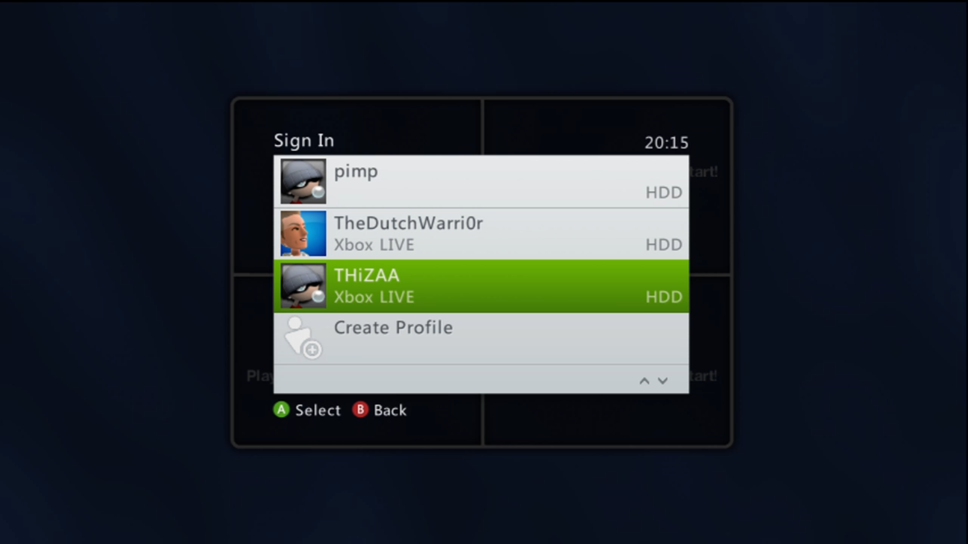  
*Figure 15 – The player is forced to sign in to a Xbox Account*  
I now select “THiZAA” as an account to log in, and so similair steps with the last 2 controllers giving me this screen as a result:  
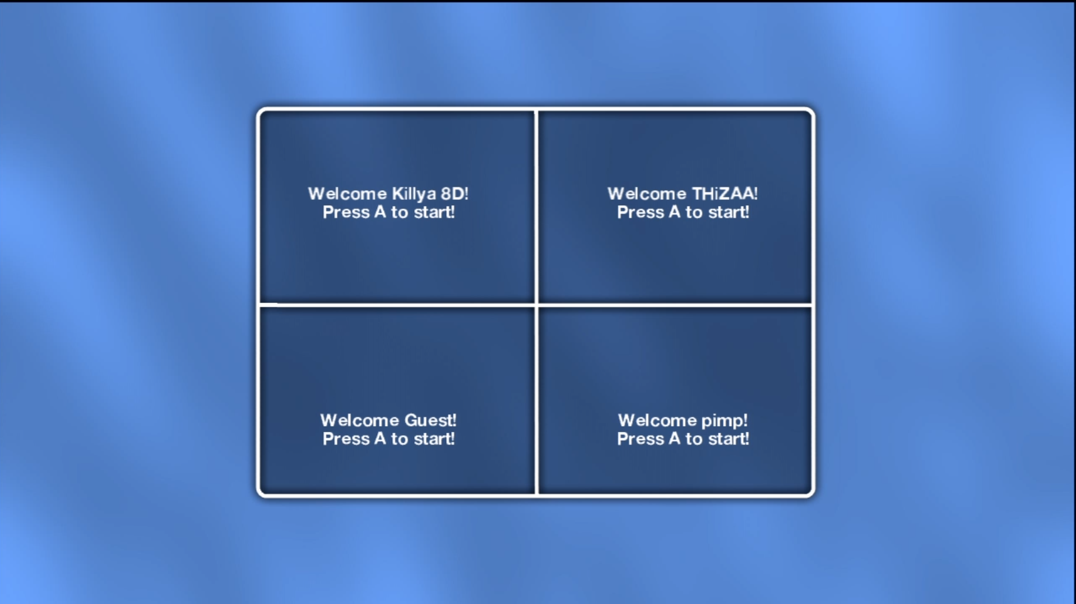  
*Figure 16 – All four players are signed in*  
Now player one is controller one, player two is controller 2 etc. But I programmed it in such a way that every position can be random. Players can still encouter problems, when after signing into the game changing accounts on the xbox itself. I want to prevent this happening by a simple method; retarting the ENTIRE game when a player signs out or reloggs. I’d like to make this happen by letting a player know by a popup, So I have to design one first!

# Creating Popups!

After disigning and designing I came up with this popup:

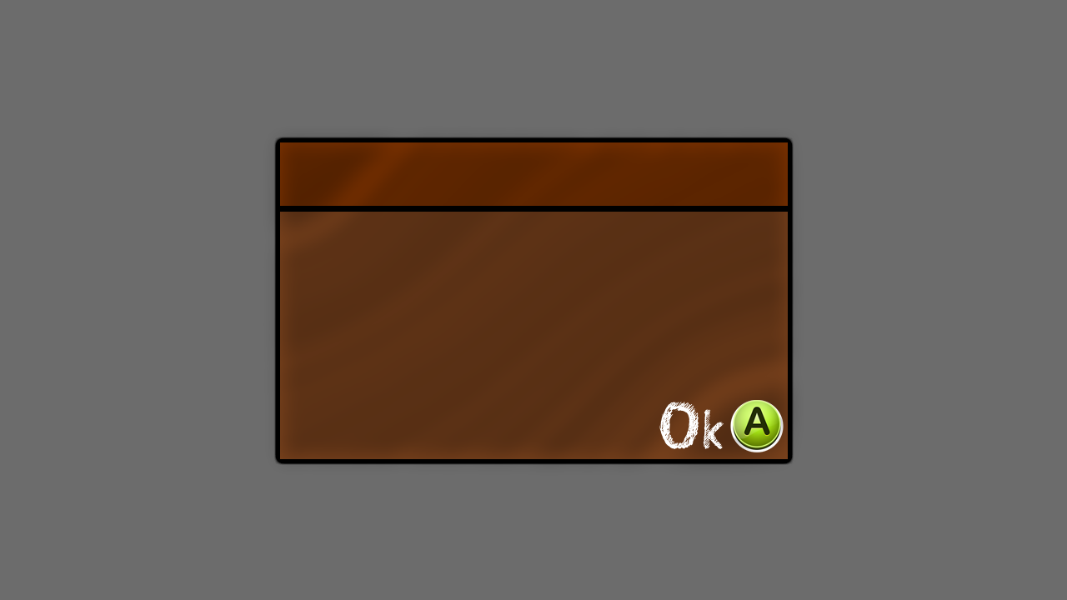  
*Figure 17 – The Popup*  
As you can see I changed the font of the letters, I will do this as well for the rest of the game. So let’s create a Popup class! After writing everything the popup code I created a popup that will show up when the player presses the “B” button, so I entered some text and a heading, which can be filled in by only this method:

**CODE:**Popup.Show(heading, message, infoPacket);

With that easy command, the popup will be shown! (Remember: I do not use anything pre-written, I wrote **everything** (including this method) myself!) So after creating the one I told you about, I pressed “B” in the main menu, and got this as a result: 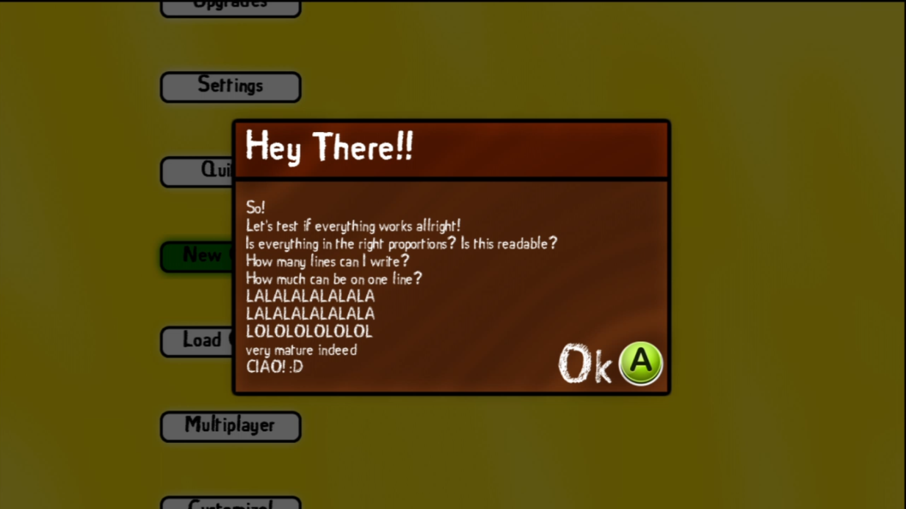  
*Figure 18 – A Test popup shown in the Main Menu*  
Do you notice the nicely dimmed background?! I’m quite happy with this popup now, so let’s continue working with this popup!

So I am encoutering some problems with detecting when a player has relogged or signed out, and I can’t fix this myself. I have posted my problems on the XNA App Hub Forum in the hope someone can help me out, so I will fix this later!

I want the game to have different arena’s, so let’s add them! But before adding them, they need to be created. I designed a few and created them, just by hand. Remember: My creativity is low, so don’t expect beautiful arenas:  
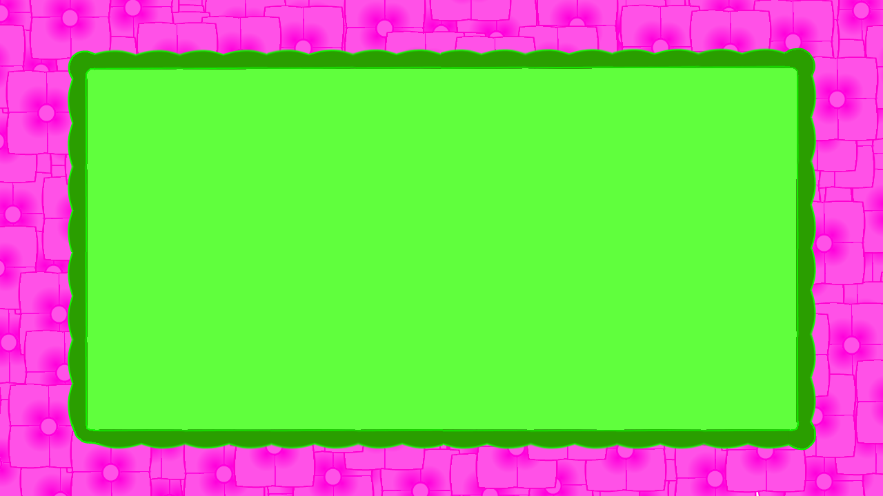  
*Figure 19 – The Coushion Arena*  
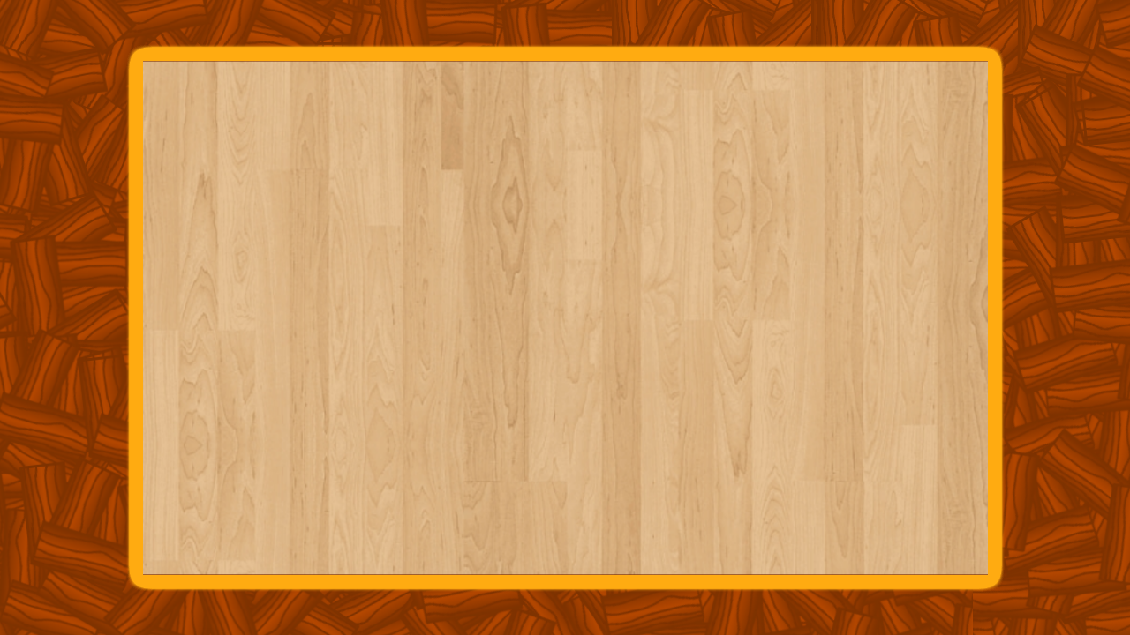  
*Figure 20 – The Wooden Arena*

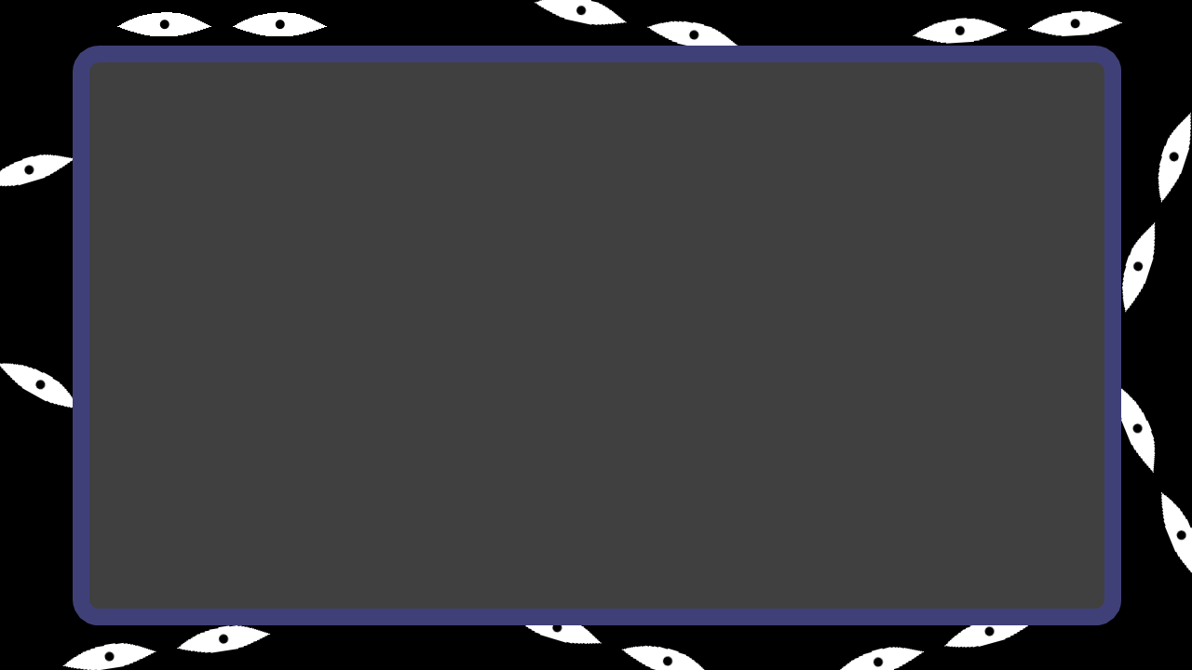  
*Figure 21 – The Scary Arena*

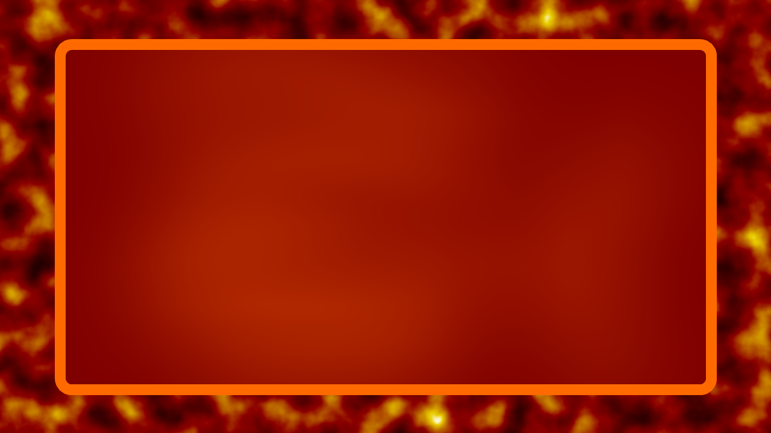

*Figure 22 – The Hell Arena*  
After implanting these backgrounds into the content folder, I need to create a “Select Arena” screen. I would like to create the Arena class first, and that is what I will do. This class needs to contain info about an arena, such as bounciness of the wall, width and height of the actual driving space, background music and a sound when a car hits the wall. So let’s create these variables and close the arena class to use further, first the “Choose Arena” screen.

In this screen I want the information about an arena displayed and a preview. This information will be stored in a personal class of the arena, so let’s create these first. Every arena has multiple variables, such as how bounciness the wall of the arena is, the name of the arena, that drivingarea which only I will use for programming and such. After making a class for every arena I am going to design the screen. Because I want to write things on the screen, they have to be clearly visible. The problem at the moment is that I don’t know which background will show, and if I use a dark font, one background will have a high contrast compared to the font and the other won’t. This is why I choose to use a different background for every screen. Not the random background. This will prevent double backgrounds as well when switching menu’s.

I want a preview of the arena, and some information to show on the arena selection screen. On the left I have a box with information, and on the right a preview. To give everything a clean look I have given them a frame and a box, as such:  
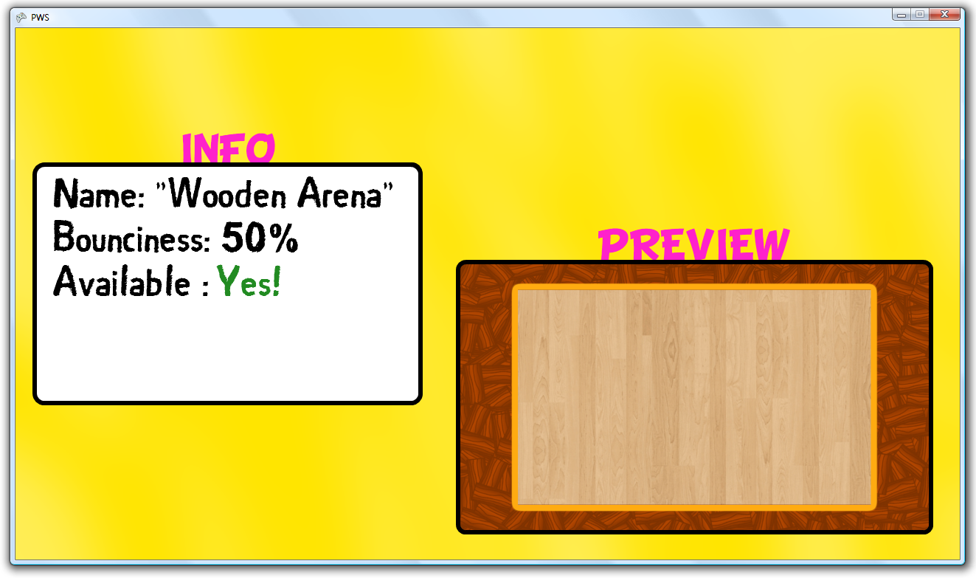

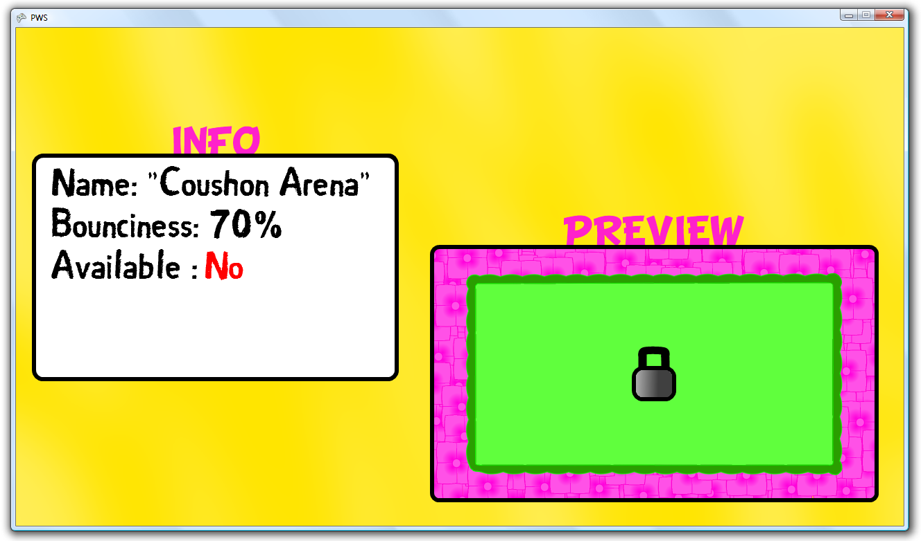  
*Figure 23 & 24 – The Arena Selection Screen*

As you can see, it show a “Unlocked” property as well. This is because I want the player to be able to buy different arena’s, thus unlocking it. When an arena is locked, it looks like Figure 24.  
As you can see there is still room free beneith the availability property. This is because I might add some features to the arenas later, if there is enough time left. This will be obstacles falling from the air onto the arena, to make it more difficult to drive for the players.

The last items I want to add is a “Continue” image and a count of the total numbers of arenas and the current arena showing with arrows next to it. These arrows need to change colours if you cannot scroll further. These will be placed beneith the Info box. If the player tries to open a locked arena I want a popup to show, telling the player that they first have to buy the arena in order to use it. See the next 2 pictures:  
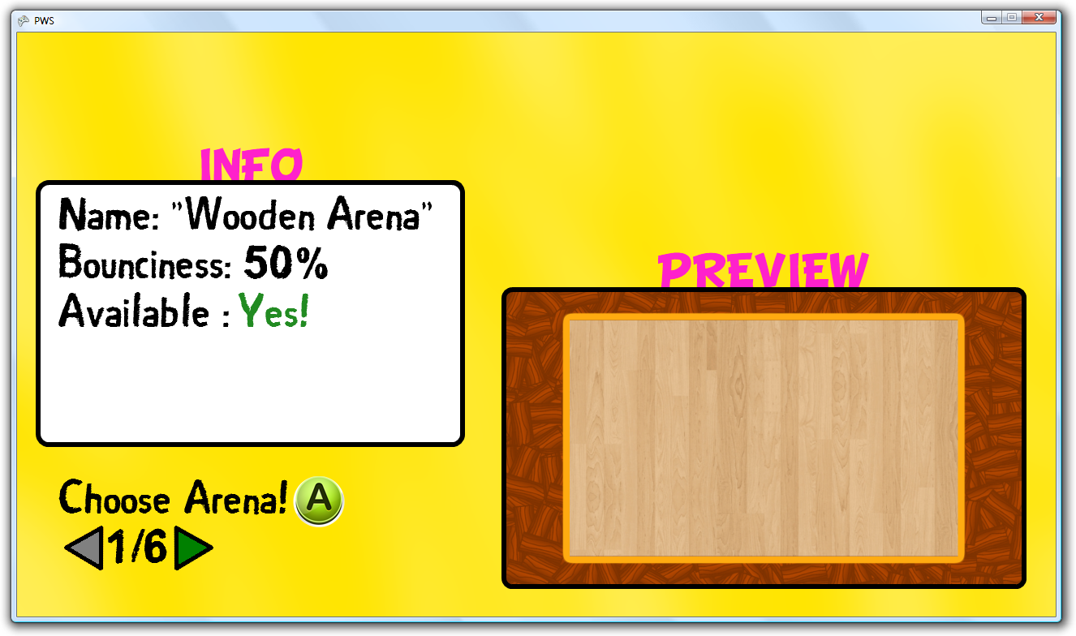  
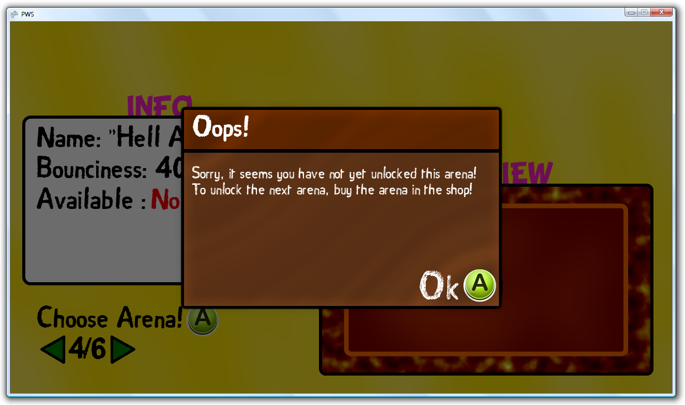  
*Figure 25 & 26 – The Selection Screen with the buttons and an error-popup*  
So if the player chooses an arena which actually is available, I want the ScreenManager to open the “PlayScreen”, starting the actual game-engine. This will be the next chapter, and the programming of the ACTUAL game, not a menu.

Remember the Forum post I told you about? Where I needed to know when a player has signed out? Well I got some answers and one helped me out! It seems stupid, but there is an actual event in XNA that will be triggered when a player signs out or signs in. I am not familiar with events, but it was quite self-explentoiry. It seems that I can create an eventHandler by writing this line:

**CODE:**SignedInGamer.SignedOut += new EventHandler<SignedOutEventArgs>(SignedOut);

This ‘adds’ a new EventHandler to the “SignedOut” event in the “SignedInGamer” class. Then the method will be trigger which is in between the brackets (SignedOut). This method looks like this:

**CODE:**void SignedOut(object sender, SignedOutEventArgs e)

{

clPopup.Show("Oohooh!", "It seems a player has changed account" +

"\nYou will now be directed back to the start screen!", ref infoPacket);

}

The parameter you see is information send with the event. I do not use these. The “clPopup” will show, with a heading and a text. "\n" is the string version of new line. At last I send the “infoPacket” as well, which contains a variable “PopupShowing” to use for any class. The “ref” part is send so the clPopup method has permission to change the infoPacket.

So now I have to write the code where the game has to be reset. I always learned that in the “constructor” of a class, you should INSTANTIATE the variables of that class, and initialize them in the initialize method. I always thought this could have been done easier, by just instantiating the variables in the Initialize class. Now I bump into a problem! If I want to reset, I can’t call the Initialize methods, because that would delete the loaded graphics as well, and to reload them would take a big amount of time. I now have to OR write custom reset code for EVERYTHING, or split the instantianting & initializing processes. I have chosen for splitting, since then there will be no more further work into the development on resetting things. I put all the instantiating in a constructor, or created a custom method for static classes, since they have no constructors. Now I just call the “Initialize” method of the ScreenManager, and this resets everything to the standard values! It now works. Let’s go and design the car or cars and make them able to drive. We will finally develop the ACTUAL game!

# Creating the game

Because I programmed the screenmanager in such a way that it can only run updates on classes which belong to a screen, I can as well run only 1 class, which can do the rest. I hope you understand what I just wrote, because it sounds illogical. I’ll show you what I mean with a scheme (See Figure 27). The screenmanager only update one item (in this case the Game). The top row of items are screens, so that scores is a scorescreen, and the scores on the bottom are the actual scores. Because only 1 item is updated, it gets all the resources available (CPU & GPU). Since nothing else is updated or drawn, the game has all the space it needs, and when programming I don’t need to think about things in screen from other screens etc. I hope this makes it more clear.

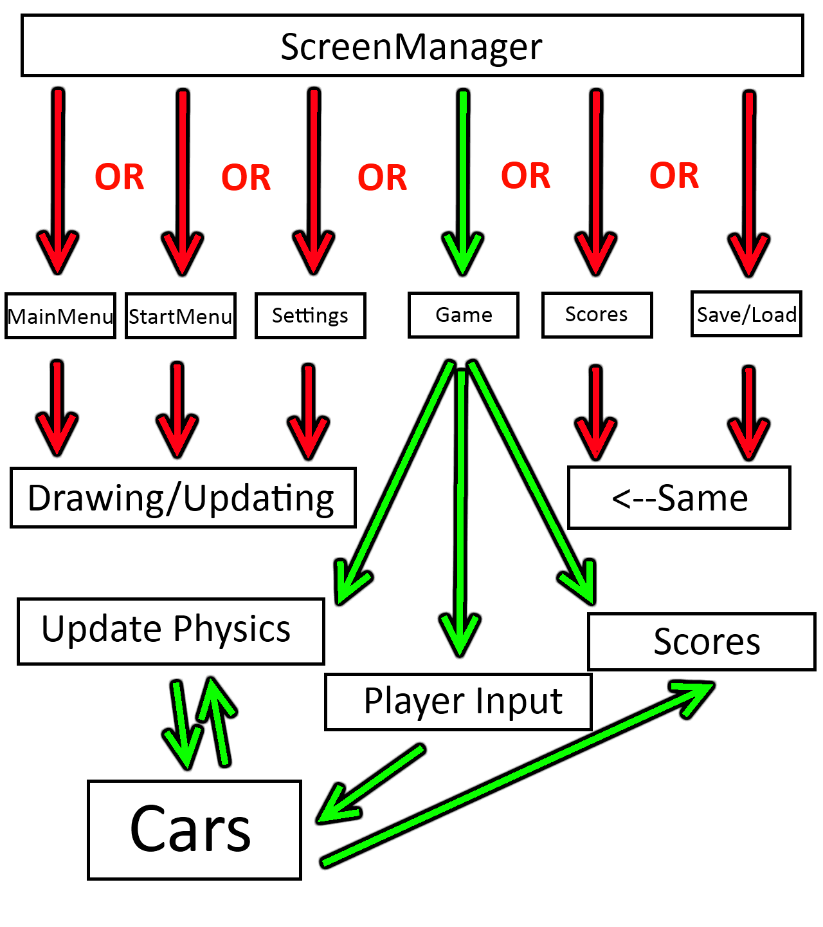  
*Figure 27 – Example of scheme how my ScreenManager works*

I now create a new folder named “GameEngine” and a class in it named “GameEngine”. I put in all the standard methods etc. I add another method as well, which looks like this:

**CODE:**static public void Start(Arena currentArena)

{

GameEngine.currentArena = currentArena;

GameEngine.currentArena.Open();

}

And

**CODE:**static public void Close()

{

currentArena.Close();

}

These blocks or code can be called by any class, which will start the arena, starting the music. I have added a custom song for every arena just to make it more attractive to unlock new arenas, which will keep the player playing.

I now call this method when in the arenaselection screen A is pressed and send the current arena with it, thus ending in a screen where the arena is shown and music starts playing. I made the arena class in such a way, that the music fades in, so there are no abrupt starts.

The first step I need to take, is to gain the driving areas of every arena. I just thought of a new problem! On the Xbox, the first pixel on the screen is not equal to (0, 0) on the drawing axis. Only this part is drawn to the screen:  
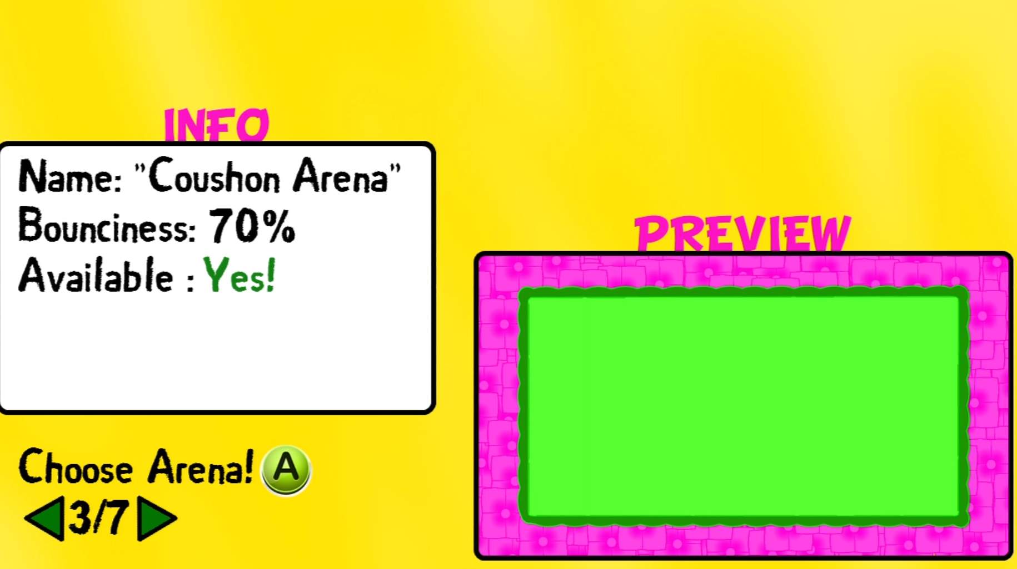

*Figure 28 – The Arena Selection Screen drawn on Xbox*

And because this is on a TV screen, the saturation is extremely high, so I can’t see contrast. It looks like Figure 29:

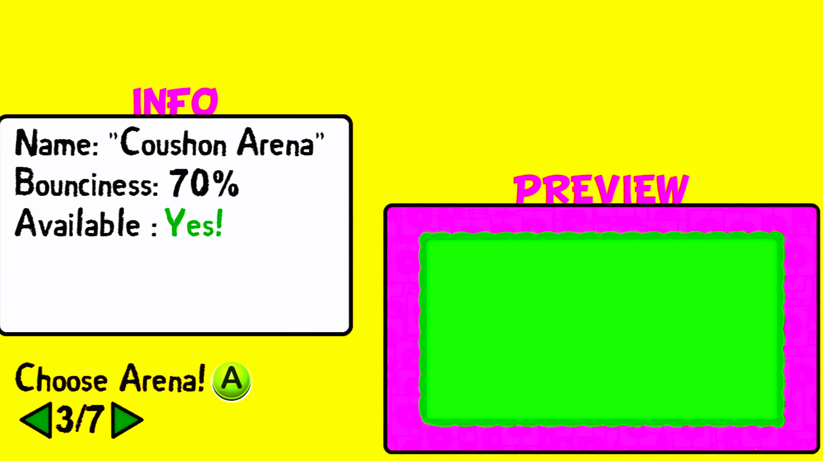  
*Figure 29 – How the Arena Selection Screen looks on the Xbox.*

The arena got equally pink, while it was build out of cushions, and the little bit if difference in colour in the background is gone as well. I don’t know how to change this, so I won’t bother with this at the moment. I check every frame for things to be out of the screen, and I notice only this screen to be out of place. For the arenas, I thought it would be worse. My plan was to put all the stats outside of the playing arena’s. Since everything still looks neat, but there is no place to draw the text, I decided to put the text inside the driving space, trying not to obstruct to much of the view. The only arena I had problems with was the Angel Arena, because it has 2 halos partially outside of the screen:

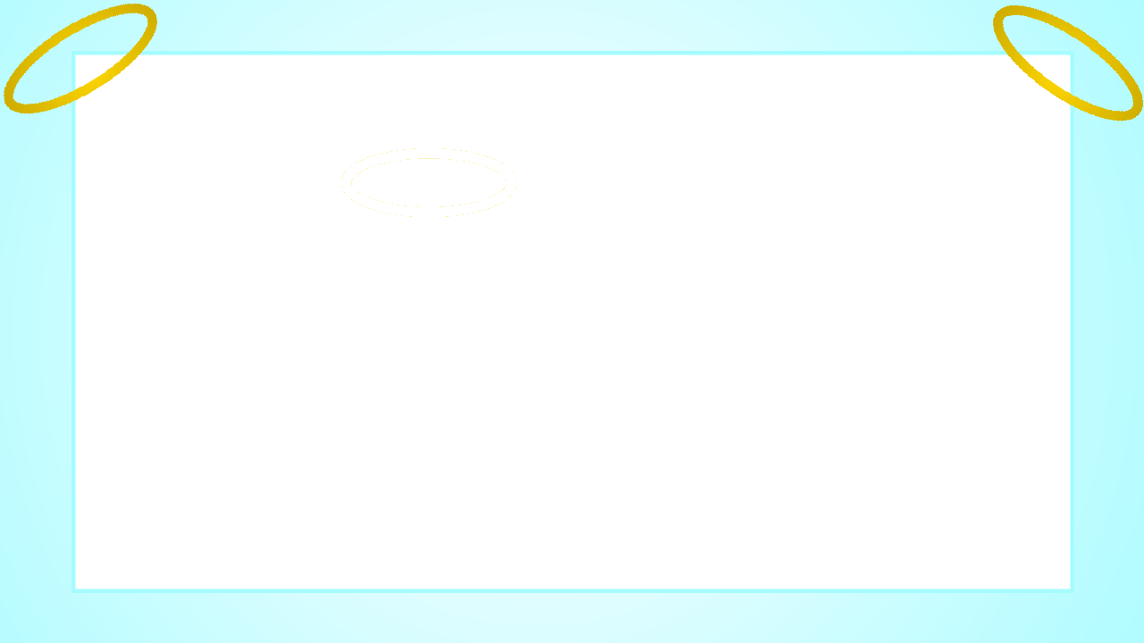  
*Figure 30 – The Angel arena with the halo’s*

I fixed this by making the driving part smaller including the halos. After all this difficult problems I finally got the driving spaces by reading from my paint program, and we can start programming the car.

First the car has to be designed. Because in the game you can upgrade your car to different cars, I want to draw different cars. Some stylish and some looking as if coming straight from the dump. Because drawing something proper has proved very difficult, I have just drawn one for now.



*Figure 31 – The First Car Design*

I want this car to be fully customizable, so I already implant a class named “PlayerStats” which contains information about a player (which arena’s unlocked, which cars, which upgrades and the name of the player). This is so I can have all this info in one variable, which can be saved as well when the game is closed to play later. The car class needs to have different variables, such as all the textures of all the classes, a number representing what player is controlling the car, if the car should be in the game. (The 4th car shouldn’t be in the game if only 3 players are playing)

Because I need the InfoPacket very often in other methods than the Update method, I made the struct a class and made it static, so I can access it everywhere. Now I can determine how many people are signed into the game and how many cars should be available. Because I want the game to debug fast, I create the code to determinate the amount of cars, but comment it out and just set the number to 2. In the car class I let car 1 be controller by controller 1, and car 2 be controlled by controller 2, although this will not be the case in the actual game. I now set start positions for every car, and give them the standard colour “LightGreen”. Only the cars which are in the game will be drawn. The starting position are influenced by the arena size, so the cars will always start inside the arena. When I start the first arena with 4 players, Figure 32 is how it looks like:

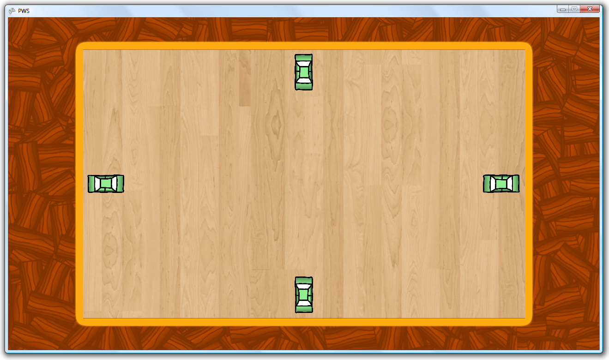  
*Figure 32 – The actual game with the four cars drawn on their starting positions*

With 2 players it looks like Figure 33:

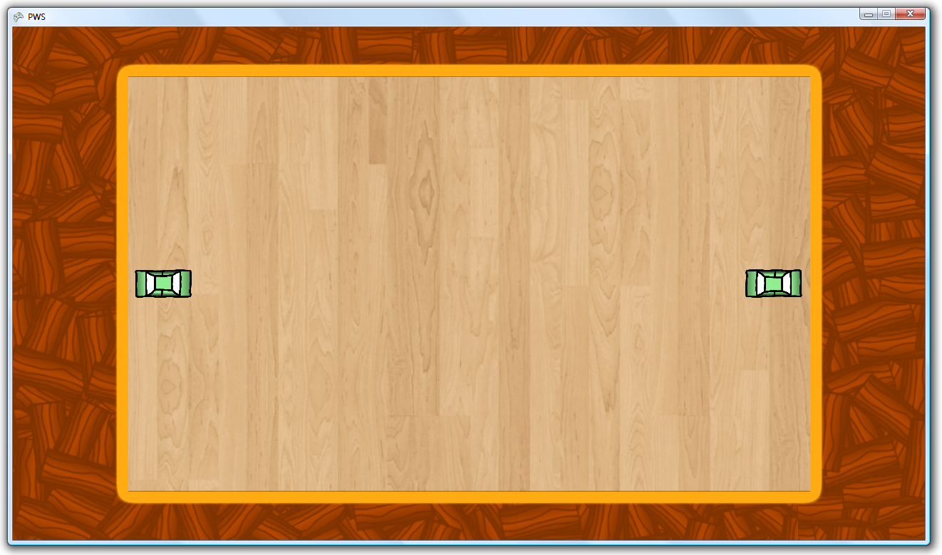  
*Figure 33 – The game starting with 2 players.*

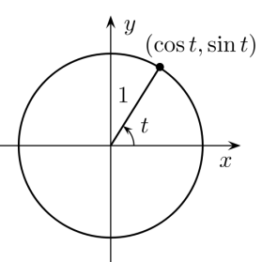You can think of the way it looks with 3 players. So now comes the math, but only an easy part. The driving! Of course I can’t say, move 5 cm forward, but only move 5 pixels up and 3 to the left. So I need to get a speed, and split that in a xSpeed an ySpeed. This is done simply by the unit circle shown on Figure 34. I put in the rotation where it says t in the picture, and I get the percentage for the speed for the x axis with sin and the y axis with cos. I multiply the outcomes and set those as the x and y speed. See this block of code: *Figure 34 – The Unit Circle*

**CODE:** //Now split the speed in a xSpeed an ySpeed relevant to

//the rotation

splitSpeed.X = speed * (float)Math.Cos(rotation);

splitSpeed.Y = speed * (float)Math.Sin(rotation);

I still feel proud because I figured this out by just my own experience, not tutorials on the internet. So now I just let the rotation change if the left joystick is moved to the right or left, and the speed will automatically adept. This is easily done because the joystick returns values just like this unit circle. If fully to the right, it will return (1, 0), if aimed to the top right it will return (). The joystick returns values split in X and Y, so I can use this to even rotate with different speeds. Now that I coded this all, I can drive the cars around! As you can see on the next page, they are rotated and changed position, but the cars can just drive through each other. I found only 1 thing that is different in real life, and that is that the slower you go, the faster you can turn! So I adjusted the code like this:

**CODE:**rotation += (int)(speed + 1) * state.ThumbSticks.Right.X * (.2f - .15f * (Math.Abs(speed) / maxSpeed)) * (Math.Abs(speed) / maxSpeed);

This way the rotation will be positive or negative ((int)(speed + 1)) and the rotation speed will be max 0.20 and minimal 0.05(when in full speed). These are the best values found after testing.

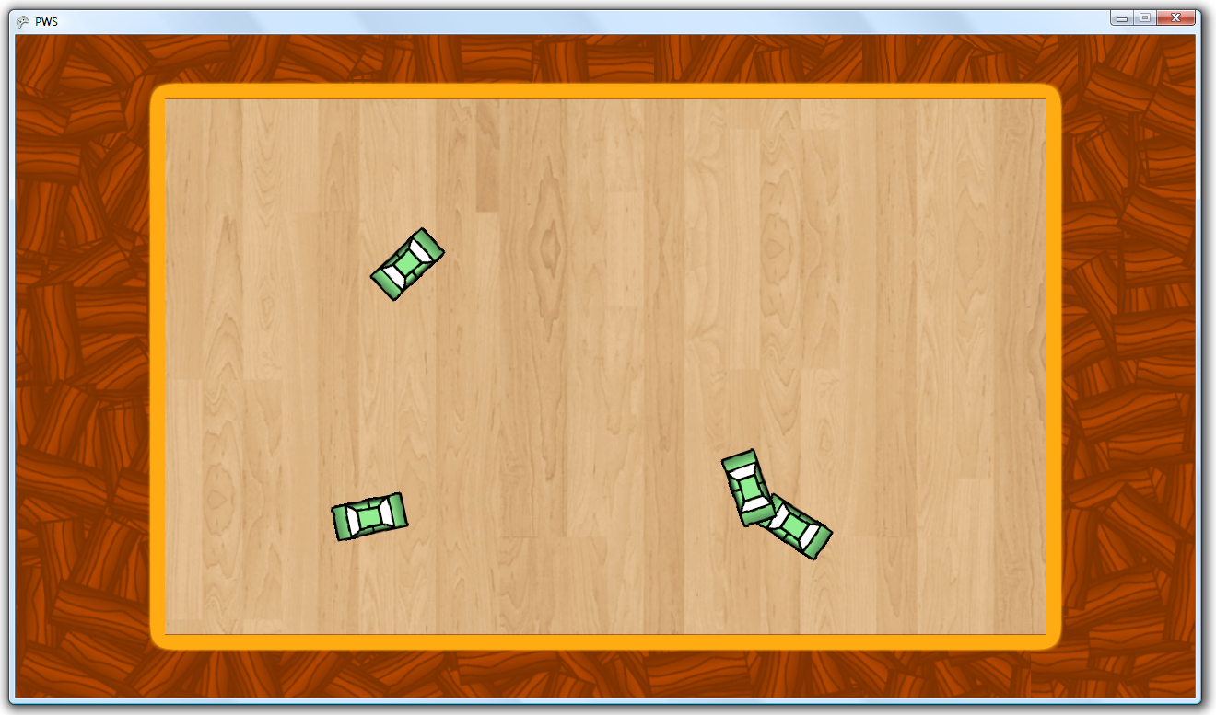  
*Figure 35 – The game without collision detection*

I now want to create an algorithm for each car so they can’t drive outside of the arena. The arena is now just something graphical, but does not actually represent any bounds. The cars can even drive out of the screen, so we need to limit this! We now begin the part with the most difficult math so far. This will not be extremely complicated math, but to figure out how to do this all by myself was a difficult task. Remember that I had **NO** help doing this, so I actually saw this an a personal achievement! The first thing to do, is to get a rectangle of a car. Now, I can get a rectangle from the XNA code, but the will only return a rectangle of the car not being turned. You cannot turn this rectangle, so I will have to do that first.

What my plan is to do, is to get every corner of the rectangle as a position in the screen. So I will have something looking like Figure 36:  
   
*Figure 36 – The car with the positions of the corners drawn next to it.*

I show the actual car so you can associate the look of the actual car when the rectangle is set in such a way. Something I know about corners of a rectangle, is that they are all on the same circle, let me show:  
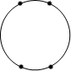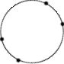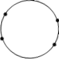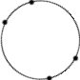  
*Figure 37 – However the rectangle is turned, the corners stay on a circle.*

As you can see, it doesn’t matter how I rotate the corners of the rectangle, they are always on the same circle. I use this to my advantage. This is the algorithm to determine the starting phase of each corner:

**CODE:** public RotatableRectangle(int x, int y, int width, int height)

{

//Instantiate the corners array

corners = new Vector2[4];

//Set every corner by hand, this can be done easily if the rotation is 0

corners[0] = new Vector2(x - width / 2, y - height / 2);

corners[1] = new Vector2(x - width / 2, y + height / 2);

corners[2] = new Vector2(x + width / 2, y + height / 2);

corners[3] = new Vector2(x + width / 2, y - height / 2);

//Instantiate the phases and startPhases arrays

phases = new float[4];

startPhases = new float[4];

//Set the position

position = new Vector2(x, y);

//Set the rotation, which always is 0 when beginning

rotation = 0;

//Calculate the radius of the circle the corners are on with Pythagoras

radius = (float)Math.Sqrt((width / 2) * (width / 2) + (height / 2) * (height / 2));

for (int i = 0; i < 4; i++)

{

//Get the delta X and delta Y of each corner

//according to the centre of the rectangle

//These will be used as a "opposite" and

//"adjectent" in the tanges solving

float dx = corners[i].X - position.X;

float dy = corners[i].Y - position.Y;

//Get the temporary phase of the corner.

//This will be the temporary phase in the bottem right corner

float tempPhase = (float)Math.Atan(Math.Abs(dy) / Math.Abs(dx));

if (dx > 0 && dy < 0)//Corner up right

{

//The temporary phase is on the top half and not the bottom half

//So because this corner is also on the right

//It's just the negative

tempPhase = -tempPhase;

}

else if (dx < 0 && dy > 0)//Corner down left

{

//This corner is on the bottem half as well, but then on the left

//It is the exact oppisite of the corner up right

//So I just add 1 PI.

tempPhase = (float)Math.PI - tempPhase;

phases[i] = tempPhase;

startPhases[i] = tempPhase;

}

else if (dx > 0 && dy > 0)//Corner down right

{

//The temporary fase is already the phase of the corner

//in the bottom right quarter, so nothing to do here

}

else if (dx < 0 && dy < 0)//Corner up left

{

//This corner is on the exact oppisite side of the corner

//down right, so I just substract PI.

tempPhase -= (float)Math.PI;

}

//Set the phases  
 phases[i] = tempPhase;  
 startPhases[i] = tempPhase;  
 }  
 }

The code should be understandable by the // comments. I now have an array of the starting phases. I now use this method to actually gain the X and Y value after adding the actual rotation of the corner:

**CODE:** public void Update()

{

for (int i = 0; i < 4; i++)

{

//Set the new phase

phases[i] = startPhases[i] + rotation;

//Calculate the X and Y value of the corner

corners[i] = new Vector2(radius * (float)Math.Cos(phases[i]) + position.X,

radius * (float)Math.Sin(phases[i]) + position.Y);

}

}

This is some basic math. I calculate the new X by getting the cosinus of the phase of the current corner. I multiply it by the radius of the circle around the rectangle (because a cosinus is always between -1 & +1) and add the actual position of the centre of the circle. I do the same for the Y value. I now have the corners surrounding my car, making a rectangle. I make the corners visible by drawing dots on them, for debugging and making the information visual. As you can see this works:

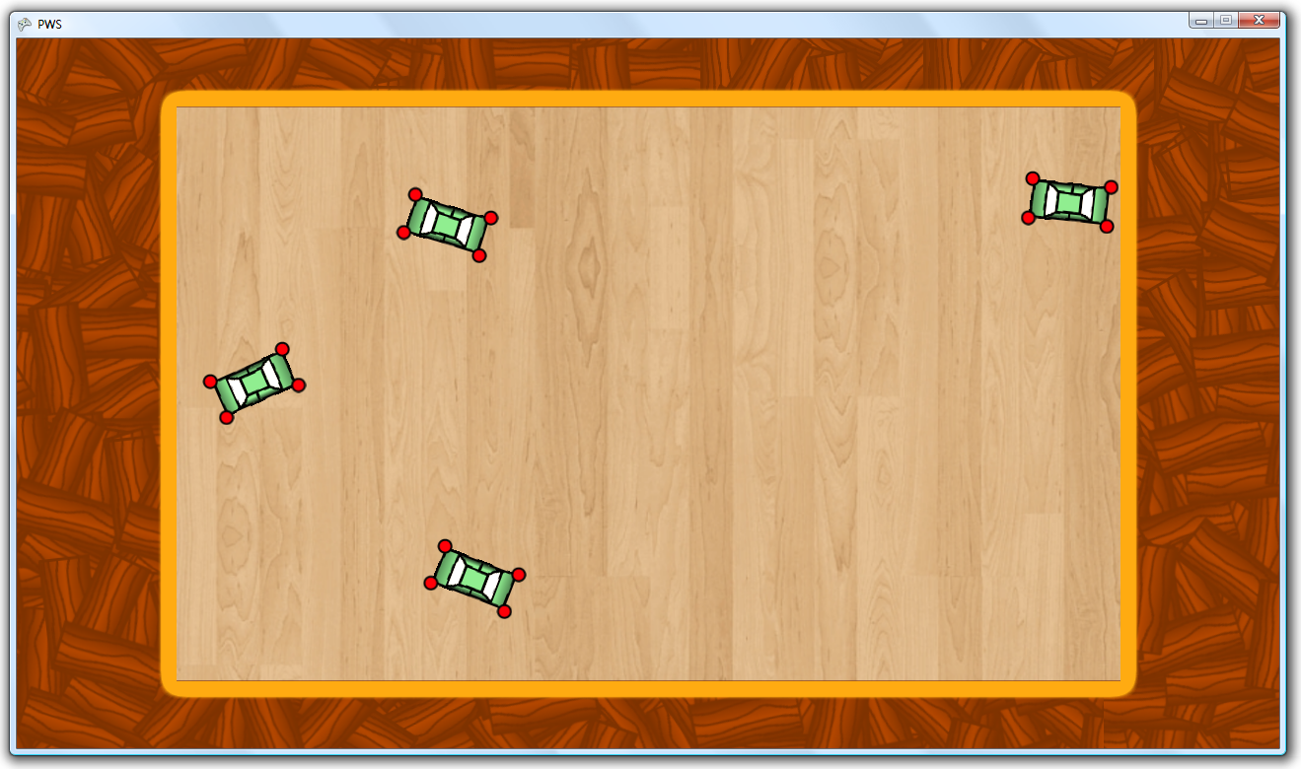  
*Figure 38 – All cars corners visualised*

All the cars are surrounded neatly by 4 dots, representing the corners. I can now use ANY size of sprite I want, and the code does not have to be adjusted. Now something has to happen when a car is out of the bounds, and the car should check if it is out of the bounds. (bounds = driving area). So to check this I wrote a simple algorithm that says. For each corner check if the X position is bigger than the right side, smaller than the X of the left side. Check if the Y position is lower than the top and higher than the bottom. If so, set the speed to the negative value, times the percentage of the bounciness of the arena.

**CODE:** public bool CheckOutOfBounds(Rectangle rectangle)

{

//Check for each corner if outside of

//the driving area.

for (int i = 0; i < 4; i++)

{

if (corners[i].X > rectangle.Right ||

corners[i].X < rectangle.Left ||

corners[i].Y > rectangle.Bottom ||

corners[i].Y < rectangle.Top)

{

return true;

//When a value is returned the code wills stop.

//This way the return false will only activate

//if no corner is outside of the bounds :)

}

}

return false;

}

**CODE:**

if (bounds.CheckOutOfBounds(GameEngine.CurrentArena.Bounds))

{

position = prevPosition;

rotation = lastRotation;

speed = -speed * GameEngine.CurrentArena.Bounciness;

}

So! It seems we can drive the cars around without being afraid of driving outside of the screen or arena. I now want to get the car to slip a bit when it drives into a wall, so I am going to try if I can make that happen.

I have something in between which is irrelevant to collision testing, but I had some friends over last night and let them drive the car around the arena. I got some feedback that they would rather see “A” pressed for giving gas and “X” or “B” pressed for reversing. I reprogrammed the game to do this, and even I found this was better than a joystick, so for now I will adept this.

So as I told you I want to try and make the car slip when driving into the wall. After writing some code, it looked neat with the front and the back. I got problems though when the right or left side of the car touched a side. Instead of driving away from the wall which I wanted when I went left or right, the back of the car rotated inside of the wall, and got stuck, like such:

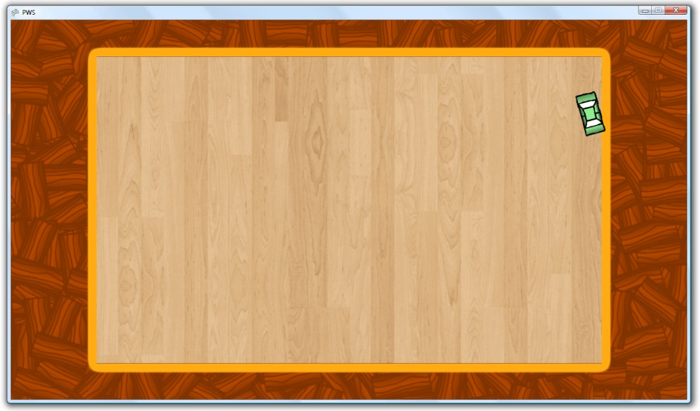  
I couldn’t find a solution to this problem so I had to cancel the attempt to slip. I saved the code though for if I want to use it later into the game!

I would now like to create the customization screen, since I   
now had enough *Figure 39 – The car is stuck in the wall*  
thinking about sin and cosinus and how to solve the slipping and rotation problems, which will be even worse with colliding cars. So now I’d like to program something simple! Like the customization menu and screen! So let’s do this! :D

I first need to change the buttons in the main menu. I now have this:

**CODE:** texts[0] = "New Game";

texts[1] = "Load Game";

texts[2] = "Multiplayer";

texts[3] = "Customize!";

texts[4] = "Upgrades";

texts[5] = "Settings";

texts[6] = "Quit! :(";

Because I only want to focus on multiplayer because of time problems I remove the “Multiplayer” option, because the “New Game” button will be the same action. I want the game to autosave after buying, customizing and ending a game. The game must also auto-load when a player signs in. So I remove the “Load Game” option. I want to have everything in the Customize screen, including the Upgrades, so I delete the “Upgrades” button as well. Now I need a button for the shop, so I add a “Shop” button, giving me this as final result:

**CODE:** texts[0] = "New Game";

texts[1] = "Shop!";

texts[2] = "Customize!";

texts[3] = "Settings";

texts[4] = "Quit! :(";

The player needs to buy items with some kind of currency, so I add a variable “money” to the playerstats class. So I want the money to show in all of the screen. I create a little display for the money. I now make a new kind of Screen Manager of the ShopScreen class. It will have multiple screens, for every upgrade menu one. And ofcourse a main shop menu! I now create a buttonlist like the actual main menu, for choosing to go to which upgrade screen. In the ShopScreen class, I’ll always draw the money display, so this can be seen in all of the upgrade menu’s. I first want to focus on the car upgrade menu. So I make a new info box, which will show all the stats of a car. The way I create this is very similar to the arena selection screen, so no further explanation is needed. I now want to show an example of the car. The way I planned to do this is by letting a car drive circles. In the car class I add multiple new methods:

**CODE:** //Method to call when this car is going to a PC-controlled state

//It will make the update method ignore any player input

public void MakeAI()

{

playerControlled = false;

}

//Method to make the car drive circles

public void DriveExampleCircles()

{

speed = maxSpeed;

simulatedLTSX = -1;

}

I now adept the car update screen, so that when playerControlled is true, it will do standard things, but when not playerControlled, it will replace the player input variables with my own variables. The Left Joystick of the playerstate will be ignored, and instead the simulatedLTSX will be used (simulated Left Thumb Stick X-value).

I actually created this to make the car AI-operatable, but due to time-limitations I can’t develop this. I create a Boolean for inExampleMode as well, because I now can just make this line of code:

**CODE:**

if (inExampleMode)

{

rotation -= .0075f * maxSpeed;

}

Because cars have different speeds the circles they will drive will differ in size. To create a steady circle I create a good balance. I draw a roundabout to make it look more nice and I have Figure 40 as a final result:

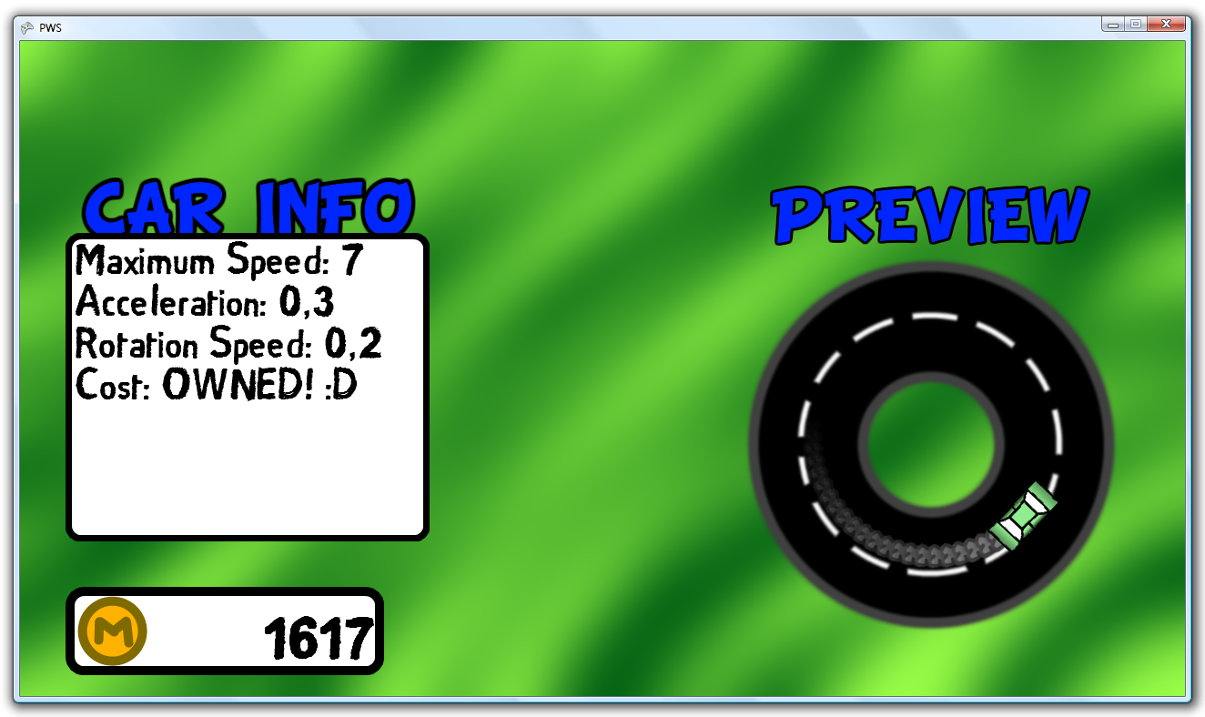

*Figure 40 – The finished car shop, without a title on top.*

As you can see there are fumes behind the car. I created these to make a cool effect. It had nothing to do with the gameplay but only with the graphics. What I do is add a new fume sprite to a list named “fumes” every 25 milliseconds. I let the sprite shrink in size slowly, and slowly fade away. The code looks like this:

**CODE:**//Time passed since the last fume, and update it

timeToNextFume += InfoPacket.GameTime.ElapsedGameTime.Milliseconds;

//If it is time for the next fume, add one to the list with the current position of the car.

if (timeToNextFume >= fumePeriod && speed > 0)

{

//Set up the actual sprite

Sprite fume = new Sprite();

fume.Initialize(position);

fume.LoadContent(fumeTexture);

fume.Origin = new Vector2(15);

fume.Rotation = rotation;

fume.Update();

//Add the sprite to the list

fumes.Add(fume);

//Reset the time

timeToNextFume = 0;

}

//Instatiate a list to delete any faded-away sprites

List<Sprite> deletableSprites = new List<Sprite>();

//Update every sprite in the fumes list

foreach (Sprite fumeSprite in fumes)

{

//If the fume sprite is nealry invisible, set it up to be deleted from the list

if (fumeSprite.Color.R < fumeFadeSpeed)

{

deletableSprites.Add(fumeSprite);

}

fumeSprite.Scale -= new Vector2(.005f);

//Since all values need to be the same, I only need to use one value, and set all 4 of the colour values to this value

fumeSprite.Color = new Color(fumeSprite.Color.R - fumeFadeSpeed,

fumeSprite.Color.R - fumeFadeSpeed,

fumeSprite.Color.R - fumeFadeSpeed,

fumeSprite.Color.R - fumeFadeSpeed);

}

//Go past all the deletable sprites, and delete them

foreach (Sprite fumeSprite in deletableSprites)

{

fumes.Remove(fumeSprite);

}

I know I do everything at random moments, but now I want to finally write the collision code and what to do after collision for the cars.

**Car Collision**

We already programmed a rectangle which can rotate and represent the bounds of the car. This rectangle is what we are going to use to check detection. I create a new method named “CheckCollision” with the parameters “Car otherCar” and “int Precision”. I want the programmer to be able to set up the precision so the programmer can adjust to the CPU power available. How lower precision how faster the method will run, but will be less precise. The CheckCollision method has to finally return a Boolean to confirm if there is a collision or not. So the final empty method looks like this:

**CODE:**

public bool CheckCollision(ref Car otherCar, int precision)

{

RotatableRectangle otherBounds = otherCar.Bounds;

return false;

}

The method is not really empty, because I need to extract the rotatable rectangle from the other car, and in the end it returns false, because if nowhere is returned true, there is no collision and the code has to return false. If there IS collision and the code returns true, the method will automatically stop!

I now want to set the corners in a counter clockwise order. See Figure 41 as an example:

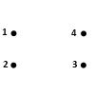 l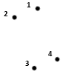 l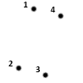 l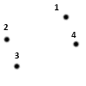

*Figure 41 – The different possible position of the corners and their assigned numbers*

So the idea is to get the highest corner, and from there work counter clockwise around. This is so I can make a logical sense of what will be the left side at that moment (1-3) and the right side (3-1). The same for the up and down side. This way I can see what is what side no matter how the rectangle is turned. So let’s create this algorithm to gain the corners in the right order. It looks like this:

**CODE:**

//Check every corner

for (int i = 0; i < 4; i++)

{

//Is the corner equal to a previously measured Y value? (The dots are on the same height)

//Then check if this corner is more left then the other

if (corners[i].Y == highestYValue &&

corners[i].X < mostLefttXValue)

{

highestYValue = corners[i].Y;

mostLefttXValue = corners[i].X;

nrOneCorner = i;

}

//If the y value of the current corner is lower than the last lowest y value

//This corner is higher. so set this as the nr1 corner

if (corners[i].Y < highestYValue)

{

highestYValue = corners[i].Y;

mostLefttXValue = corners[i].X;

nrOneCorner = i;

}

}

The comments should explain everything, we now have the nr of the first corner. With this simple code we can fill in the corners in order for the first rectangle.

**CODE:** //Now fill in the corners in order

int currentCorner = nrOneCorner;

for (int i = 0; i < 4; i++)

{

cornersInOrderC1[i] = corners[currentCorner];

//Set the next corner as the current corner

currentCorner++;

//If we are currently getting the 5th corner, we will get an error.

//The 5th corner should be the first, so:

if (currentCorner > 3)

{

currentCorner = 0;

}

}

At this moment we have the first set of corners in the right order. I can easily copy the same code, paste it under this code, and change the cornersInOrderC1 to cornersInOrderC2, and reset the highest and most left values for the new rectangle. We now have both corners in order!

So what my plan is to do, is set a new point on every side, to check against the same points on the other rectangle. The amount of points on a side is the amount of the precision parameter. How I do this, is by getting the difference between 2 points in X and Y, and divide this by precision, so I know what the position of the next point on that side will be. See this code for further explanation:

**CODE:**

Vector2[] leftSide1 = new Vector2[precision * 2];

//Rectangle 1, Left side, corner 1 to 2

dx = (cornersInOrderC1[1].X - cornersInOrderC1[0].X) / (precision + 1);

dy = (cornersInOrderC1[1].Y - cornersInOrderC1[0].Y) / (precision + 1);

//Filling the array

for (int i = 0; i < precision; i++)

{

leftSide1[i] = new Vector2(cornersInOrderC1[0].X + (i + 1) * dx, cornersInOrderC1[0].Y + (i + 1) * dy);

}

I first create an array for the left side of the 1st rectangle. Then I calculate the difference in x per vector, and the same for y. Then I go past every point and set the vector. I hope this doesn’t sound too complicated. With some temporary un-important code I draw a dot on every point on the sides. The corners are red, and the dots on the edges are green. I repeated the code above for both rectangle, and every side. Another thing you might ask yourself is why did I do (precision + 1)? This is because there are X dots on the line, plus another dot which is the next corner. If I would just have chosen precision, the X’th dot would be the next corner! So now we can see how it looks like with 2 different precisions!

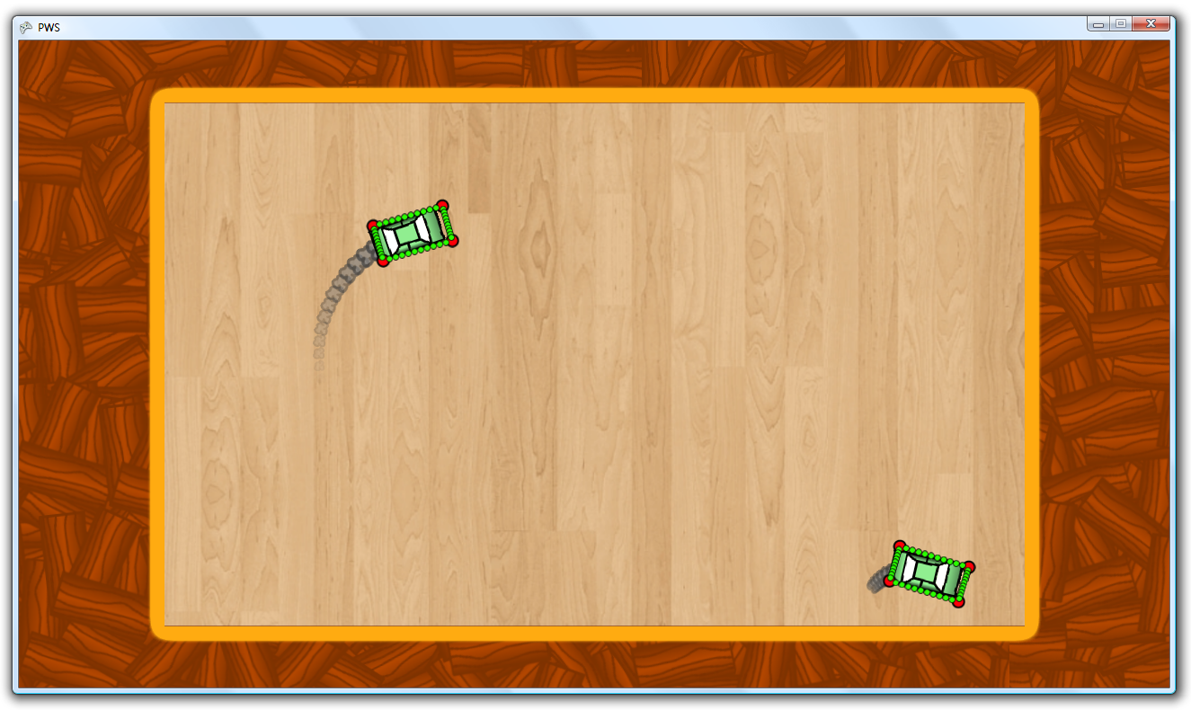

*Figure 42 – Both cars in action with a rectangle of precision 10. Good frame rate here.*

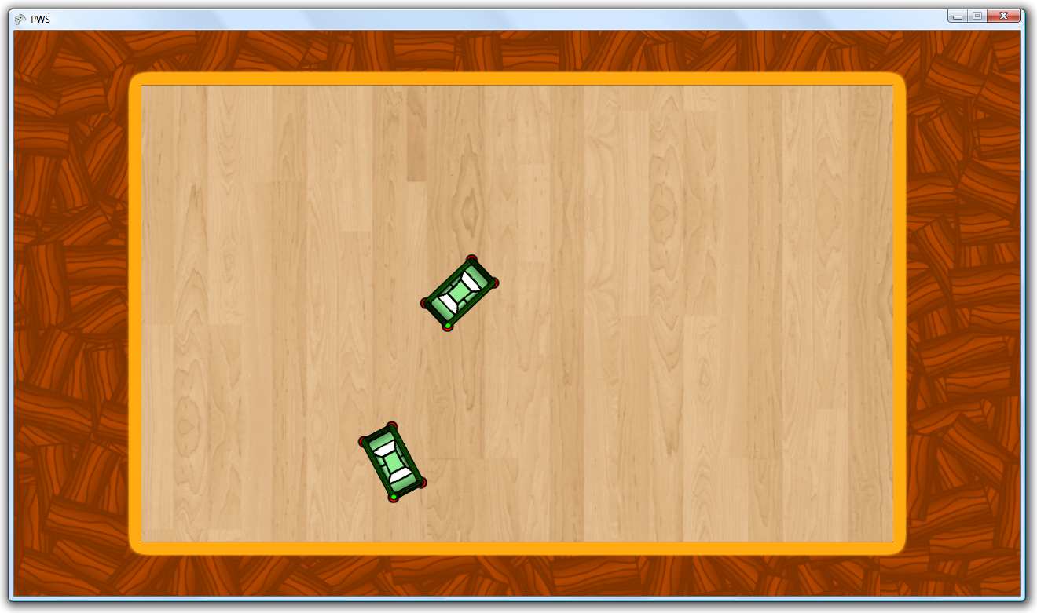

*Figure 43 – Both cars standing still with a rectangle of precision 100. Low frame rate here.*

As you can see the precision of 10 will suffice. The funny thing is that I only changed the precision by changing only 1 number. So now finally the code for checking if one rectangle intersects another!

What I am about to use is a method I thought of myself, which I based on the Riemann Integral. This is a method meant to calculate an area. See figure X for an example.

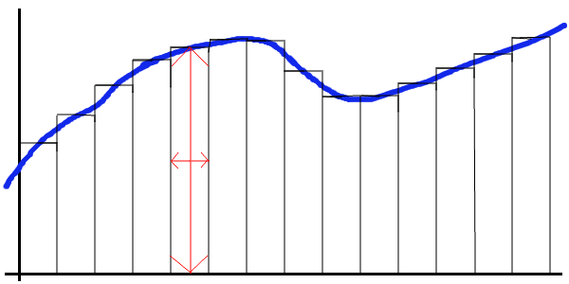

*Figure 44 – a Riemann Integral*

The width of the rectangle, stands for the precision. The less wide the rectangle, the more you can have, and the more accurate your calculation is. I want to use this for my collision testing. What I do is create imaginary rectangles on the edges, with the length of the radius of the rectangle (maximum length). I will place these rectangles on the left side, going to the right, and vica versa. Where these rectangles overlap, is the actual area of the car, but not very precise. The higher the “precision” variable, the more precise this calculation is. Please see figure X as an example. Remember that this is just a drawing by hand. This will not show in the game, and this is not very precise (3,5 here).

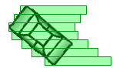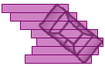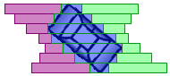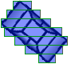

*Figure 45 – The way I get the area, but visualized*

I now check every 2 squares from one car, point on the edges of the other car. When the point overlaps a square on the right and the left side, there is a collision! The only problem I have to deal with now, is what side is hit?

So what I have done, is that the method “CheckCollision” does not return a Boolean, but a position(the position of the point which has registered the impact). I can now calculate the angle of impact from the position of the car. With tanges I can find this angle, and adjust it, because tanges only ranges from +1/2π to -1/2 π. After that I subtract this angle from the rotation of the car, which gives me the angle of rotation from the aspect of the car. I now calculate the angle of the front corners of the car, again with tanges. If the angle of impact is in between these corners, the impact is from the front, if the car is driving backwards, I will do this for the back corners. Now I know, that if a collision is with the front, this is because the player aims towards that player, OR because the player stands still. So I now have my code to check for collision, and if the collision is done on purpose and by who! Now if the car hits someone on purpose, that other person gets damage, and momentum, making the car move slightly to the direction the attacker was moving.

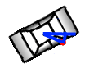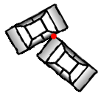

*Figure 46 – The process of finding the corner of impact and checking if it is the front.*

How I calculate the decrease of health is by the following formula:

**CODE:**

otherCar.DecreaseHealth((int)(damageFactor * speed));

The damagaFactor is by what factor the damage is done. A better car has a higher damage factor, and upgrades make the damageFactor higher. I now want the health to be displayed on-screen, but yet inside the bounds of the Xbox screen. I want to do this by drawing the health on the floor of the arena. I make the text transparent so it will blend in with the background. In every corner the health is shown of another car. See Figure X as an example.

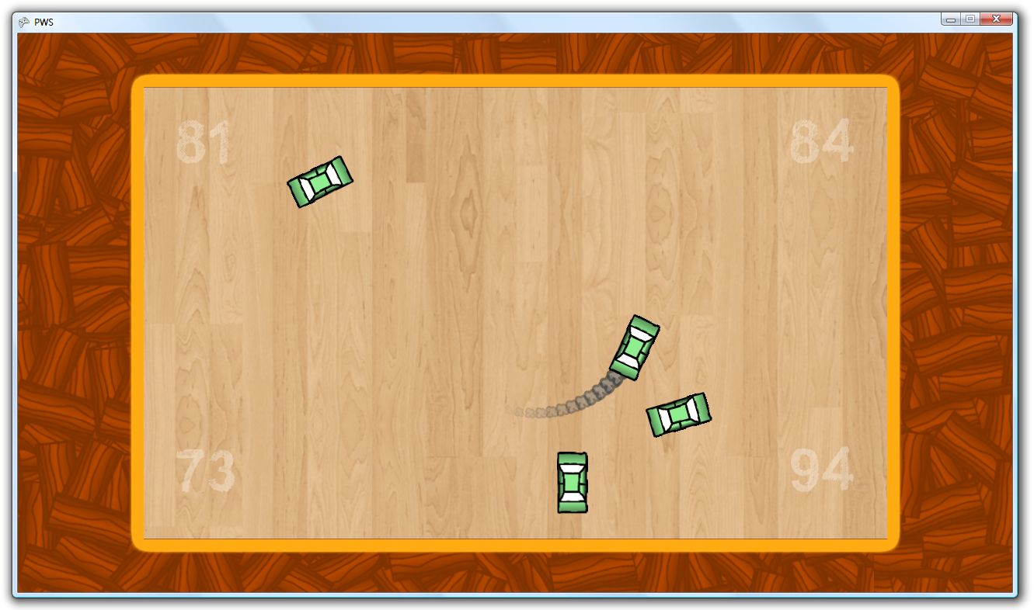

*Figure 47 – The health is shown of each car in a different corner*

For every arena I need to have a different colour, because white does not contrast on white (Angel Arena), I would need a different colour for that arena.

The next thing I would like to add to the game is something for when the game is over. What my plan is, is that the background will get dark and showing the final results over the entire screen. I want the time alive shown, the health remaining, the damage dealt, the money gained and the current money of the player. I position this nicely. I keep track of the car’s in-game time by doing this:

**CODE:**

//Update the time in game

if (currentHealth > 0 && !(GameEngine.State == EngineState.Ended))

{

msAlive += InfoPacket.GameTime.ElapsedGameTime.Milliseconds;

}

For example, after a game with 2 players, I get this as a result:

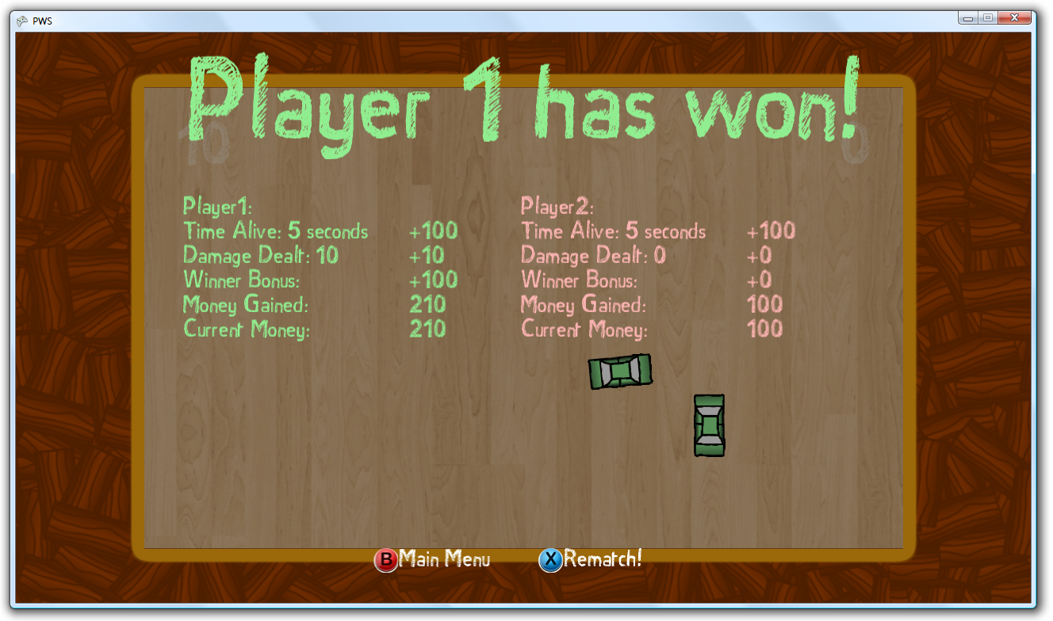

*Figure 48 – The final result screen*

As you can see I added a rematch option and an option to go back to the main menu so you can shop for new items or play in a new arena! Starting a rematch is very easy because I made a methods named “Start” that contains a custom initialization code for when the game actually starts! If I call this method all will be reset. So at this moment I have the in-game game nearly finished!

The last thing I want to add to the game is a pause menu. I want it to be similar to the ending screen with the background. I want a black transparent background, and in white the options available. The option that is changing colour is the option selected. I only want the options “Continue”and “Quit”. I stop all the things about the car when the game is paused, making my pause screen look like this:

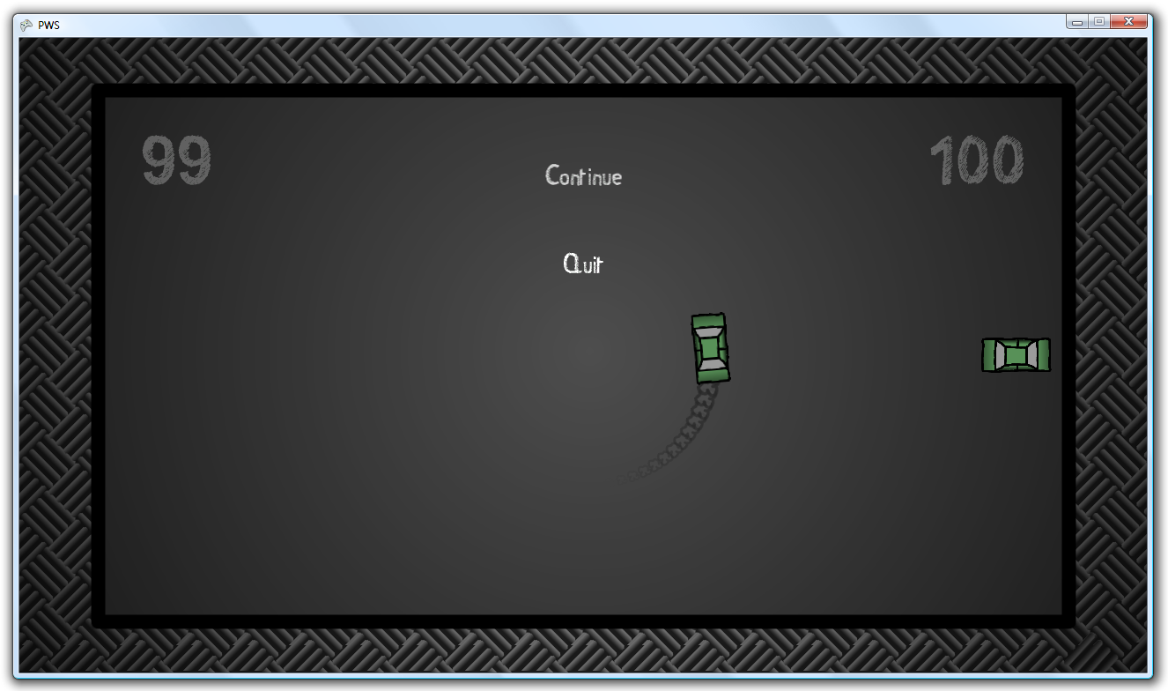

*Figure 49 – Game when paused. Continue is currently selected.*

I now need to add upgrades, cars and finish the menu’s. After this will come the saving and loading, transfer and debug the game on Xbox, playtest the game, and publish the game!

The first thing I would like to do next is finish the arena shop. The code would look very similar to the arena selection screen, only then the addition would be the showing of the prices. After some coding and copying I got this screen as a result:

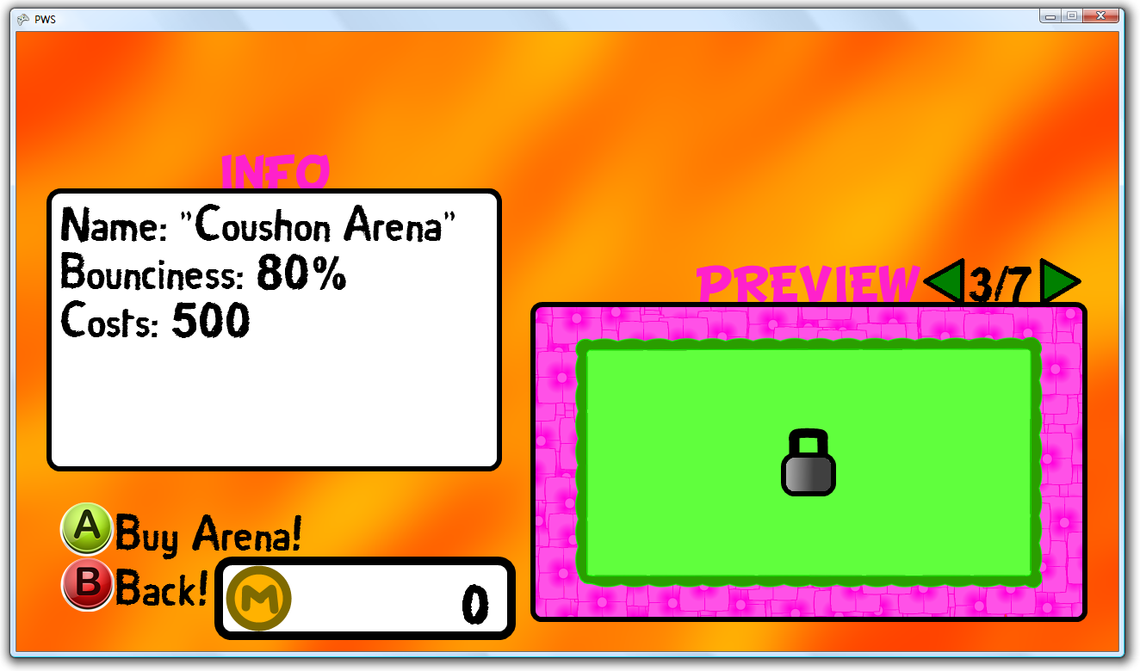

*Figure 50 – The Arena Shop*

As you can see the contrast of the text with the background is not high enough, so I switch this background with another background, to create contrast. As you can see I also repositioned the money display, only for this screen. This because I would like to keep the button suggestions at the same spot.

At this point I want to develop the upgrades. First I will create a mine, then a rocket, and after that a controllable rocket (controllable by the sender). I will have to design the upgrades first prior to programming the classes. I first decide that the upgrades will be “dropped” or “fired” by pressing down the right trigger. So first I create something that will check for this:

**CODE:**

#region Check if fire weapons/upgrades

if (state.Triggers.Right > .3f && InfoPacket.PreviousStates[playerNumber].Triggers.Right <= .3f)

{

switch (InfoPacket.PlayerStatistics[playerNumber].OffensiveUpgradeUsing)

{

case 0:

GameEngine.DropMine(this);

break;

case 1:

GameEngine.FireRocket(this);

break;

case 2:

GameEngine.FireCRocket(this);

break;

default:

break;

}

}

#endregion

As you can see, when the right trigger is pulled, the Game Engine should drop a mine or fire a rocket, and sending as parameter a car, so in this case “this”.

Now I obviously need to draw the images first, so I created a mine, which is blank. See Figure 51. Now I draw a white dot on this, which I will save on a separate image. I will use this white spot as a light on the mine. See Figure X *Figure 51- Mine*

for the finished product. I draw a kind of circle which will act as a “blast” when the mine explodes. See Figure X for this image. I now load this into sprites in the Mine class, and draw them over each other . I create a “PostDraw” method, because the mines *Figure 52 – Finished Mine* need to be drawn first, then the cars, and then the explosions. Now I can call PostDraw after drawing the cars.

So I need to find a collision between the explosion blast and the cars, and the mine and the cars. So how do I do this? Very easy!

*Figure 53 - Explosion*

I copy the code from the Rectangle vs Rectangle collision testing. I delete all the statistics of 1 rectangle, and create a new array, but then for the edge of the circle. I first calculate the phase between each point by:

**CODE:**

//Get the phase between each dot

float phase = (float)(2 * Math.PI) / (precision * 4);

I then start a for iteration for i = 0 to i = (precision * 4). Then I can calculate the phase of a dot by multiplying the phase of 1 dot by i. With sin and cos I can calculate the X and Y coordinates, multiply these by the radius. Add the positions to the center of the circle, and I have all the positions in order!

**CODE:**

//Get the position on a unit circle, multply it with the radius, and add the centre of the circle

for (int i = 0; i < precision * 4; i++)

{

edgesCircl[i] = new Vector2

(

(float)(radius * Math.Cos(phase * i)),

(float)(radius * Math.Sin(phase * i))

) + position;

}

I now check every point of the circle as the same method as every point on the 2nd rectangle in the rectangle vs rectangle check!

Great! So now I only make sure the explosion increases, and disappears the closer the radius comes to the variable I created which contains the maximum size the blast should have. I then calculate the angle of impact for the cars, and give momentum in the opposite direction by calculating with Cos and Sin, with multiplying the result by maximum speed (25) times (1 – (percentage completed of explosion)).

So now I would like to program the rockets. First of course a design. I just draw the rocket out of the blue, with no inspiration really. The final design is Figure 54, which shows the “controllable” variant as well. I use the same exact code as the mine for the explosion, and use the method of sin and cosinus to determine the speed on the x-axis and the y-axis. When the rocket hits a car or a wall, the rocket explodes. I make the radius of damage a bit more, and double the damage.

Now the weapons need to get a delay as well, so the player can not fire endlessly against the other player. *Figure 54 – The Rockets*

After some testing with my little brother, we found out these were the best options:

* Mines : 5 Seconds
* Rockets : 10 Seconds
* Controllable Rockets : 15 Seconds

This might not seem like a lot, but because the game is fasted pace these are the perfect values.

So we have the offensive upgrades, let’s create the shop for this! I use the very same method as the car shop and the arena shop. The player can scroll to options, and there is an info box and preview. I make a special box for the preview and position this so that the weapon is in the middle. In the info box I put some information and let the preview rotate. See figure 55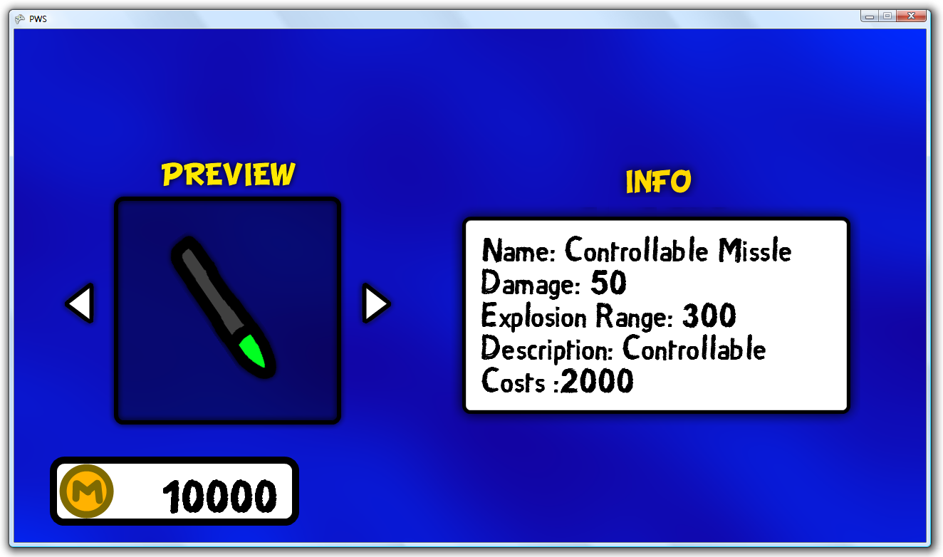  
*Figure 55 – The Offensive Upgrade Shop (I have 10.000 money for testing)*

Now I want to create the defensive upgrades. What I want is that the upgrades function as a shield. I first had a plan in mind where the shields would be some sort of bumpers mounted on the car. These where my initial designs:



*Figure 56 – The initial defensive upgrades*

When I placed them under the car (so the things aiming towards the middle go under the car, which made it look like as if those connected the car to the bumper), it didn’t really look like what I had hoped, except for the shield I created. The shield looked very stylish, so I decided to make a multitude of shields. The design would look the same, but the colour combinations would be different. The final shields look like this:



*Figure 57 – The shield in order of strength*

I actually only drew a white shield, and white glow, and use the Color property for the colouring. I have in the shield class a variable named “strength” and I switch trough this number to change the statistics. If the strength variable is 0, the car gets the bound size of itself, otherwise of the shield (so not the glow). First the health of the shield decreases, and after this the health of the player decreases.

I now need to create the shop, I use the same roundabout as I used for the car shop. I also use the same buying and selling technique as I used in previous shops, so this is easily created. I only need to decide on the prices, and program the shop!

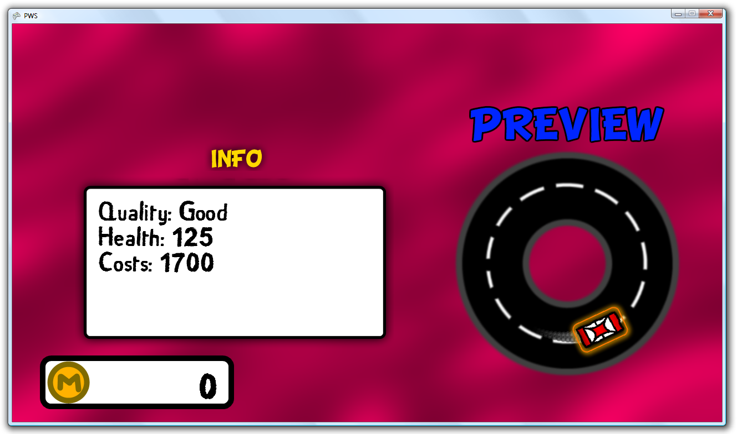

*Figure 58 – The Shield Shop*

Because I now only use shields, I rename the “Defensive Upgr.” Button to “Shields”. I also remove the “Engine Upgrades” option, because the upgrade of the car is the same. The last thing I do is change the name “Offensive Upgr.” To “Weapons” since this sounds better.

So now I noticed a horrible bug, where the cars would hit, and the hit would register, but still they ignored the hit, even if it included the front. So I wanted to visualise where the hit would take place. Since my “Collision” method returns the position as a position, I created a list which would contain all these position and they would be visualised by dots. Giving me pictures like this:

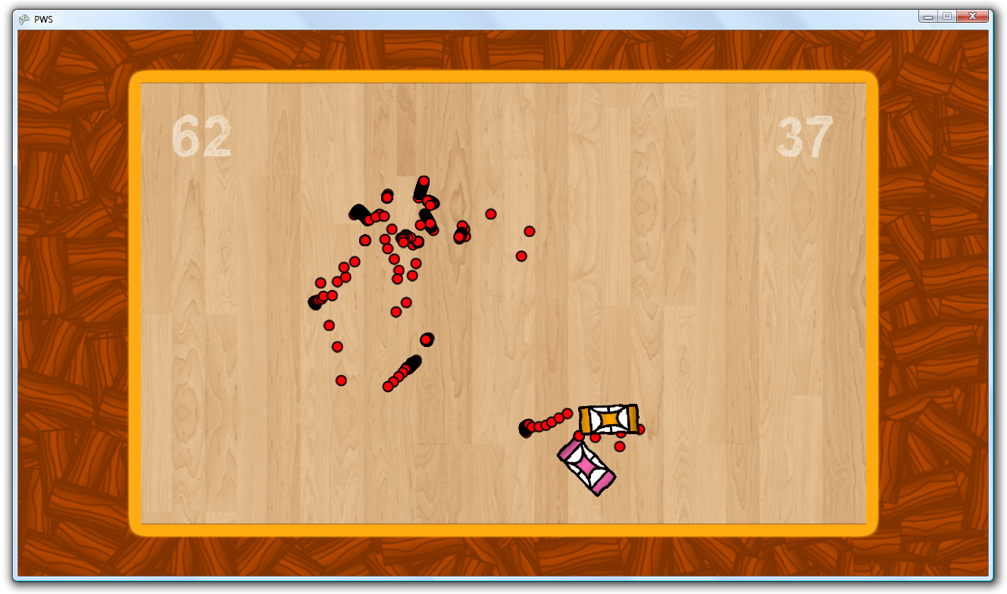

*Figure 59 – The collisions are visualised*

As you can see, there are very close groups of hits, and this is where they hit, but do not take action as a hit. Now what I noticed in the code is that I wrote this:

**CODE:** //Set the range of the angle between 0 and 2*PI

while (angleOfImpact > 2 * Math.PI)

{

angleOfImpact -= 2 * (float)Math.PI;

}

while (angleOfImpact < 0)

{

angleOfImpact += 2 * (float)Math.PI;

}

So I keep the angle of impact in the range [0, 2π]. Then in the code I use to check collision was:

**CODE:** if (relativeAngleOfImpact < frontCornersAngle && relativeAngleOfImpact > -frontCornersAngle)

{

position = lastPosition;

otherCar.TakeMomentum(splitSpeed + momentum);

otherCar.DecreaseHealth((int)(damageFactor * Math.Abs(speed)));

damageDealt += otherCar.lastHealth - otherCar.currentHealth;

speed = 0;

}

Can you see the problem? The frontCornersAngle, ranges between the positive and the negative, so: [x, -x]. While the relative angle would be [0 ,x] & [2π – x, 2π]. So I need to adjust the checking of the code to this, and my problem is solved!

So now the last graphical thing I need to add is a customization menu. I know I have 4 things you can change about the car, the colour, the car itself, the weapon, and the shield. I create one array with the same and same arrow over again. Then every odd arrow, I flip horizontally (can be done with the XNA framework). I then draw every couple of arrows on top of each other, which will be used to scroll through the car properties. I create all the examples to scale, and use my lock image. I make the code so that the code remembers what is selected on what height, and shows the example. If the player changes to an item he owns, it is immediately applied to the car. Otherwise nothing happens. Now I use the roundabout again, but this time with how the car actually looks, and not the preview of the shop. Figure 60 is the final result.

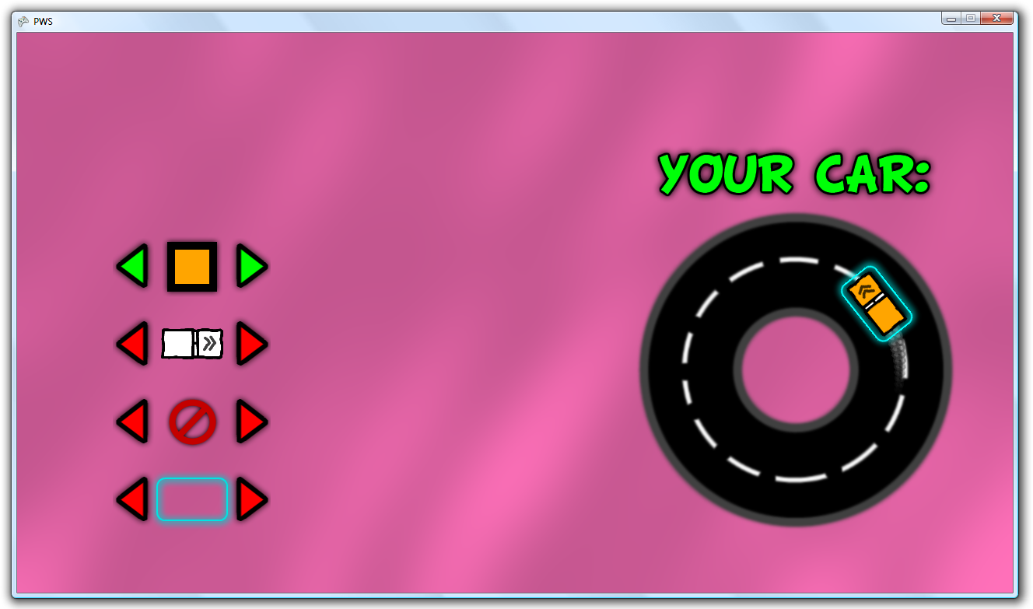

*Figure 60 – The customization screen*

I changed my mind on the settings screen. I do not want it anymore, since everything feels correct now, instead I want a credits screen because of legal reasons. I do not plan on publishing the game, but I do want to approach it as if I were to publish it. Because of that I can’t just use anything. I used songs from sources which provided them as royalty free, if the user would mention them and the site in their product. So I do this in the credits screen.

I need to get some audio fragments to play when cars hit the wall, buttons are pressed and cars collide with each other. I use the website “SoundBible.com” for this, which has an enormous amount of high-quality sound effects. I can all load them in to a “SoundEffect” variable, which I can play individually. I trigger them next to the code that gets triggered when something happens.

Now the game is at the stage where the Alpha Testing phase begins! I have asked 3 friends of mine to come over in my vacation. I made sure every save file was deleted before they started the game, and joined them. I did not explain anything to them, since any new player who would buy this game have no-one to explain the way the game is played to them. I asked them to test everything thoroughly. They should sign out on the Xbox and sign in again. Another new thing was that the game would be played by 4 people, and not the way I did it; test the game myself with 2 controllers. We had a great time and laugh, and I found some new bugs and had some feedback.

Bugs:

* The wrong player would have the wrong resources in the shop (e.g. player 1 would shop for player 3).
* Some of the cars were too strong.
* Some of the cars would keep doing damage if it would drive against a non-moving player.
* When restarting the game, wrong save files would be loaded

Feedback:

* Create different arenas in different shapes (Circles, Triangle, Random shapes)
* Unlock Arena’s not by buying, but by playing games.
* Start with a small amount of money

I especially found the feedback on how to unlock the arenas very interesting. It would attract the players to play more. I also had the problem that new arenas could be unlocked by player 1, so this person would have to use up his money on arenas, while others do not have to do this. They can spend this money on other upgrades, so player one would be disadvantaged. The start with a small amount of money was a good idea as well. When we started playing the game, it took at least 2 games to have enough money to buy something. With a small amount of starting money you could buy something immediately, or save for more. This made the game more exciting since the player does not have to play on the most boring level for multiple games.

I fix these bugs as far as I can, and now I see the game in a state of finished. Since I do not publish my game, I can and will not develop it any further. Thank you for reading this attachment, and I hope it was interesting!